Lab No | 6,7
Name | Noor Fatima
Reg No | 23_NTU_CS_1083
Semester | BSCS(6thA)
Subject | Web Development
Submitted to | Sir Abdul Basit
Submission Date | 09_03_2026


Computer Science
National Textile University Faisalabad

Lab NO 6|7

Question. No.1
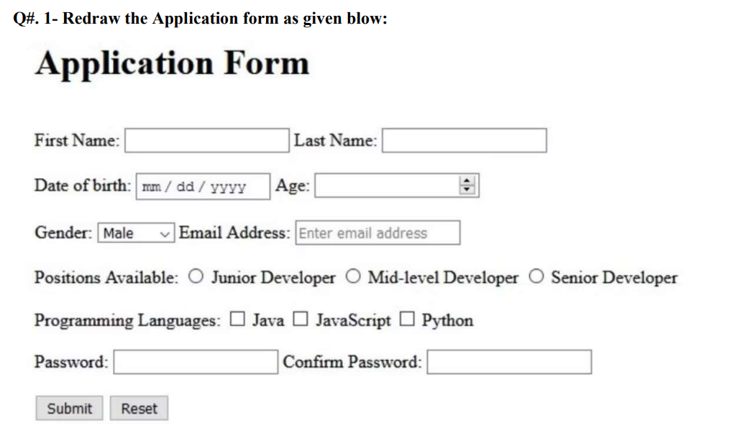
Code:
<!DOCTYPE html>
<html lang="en">
<head>
<meta charset="UTF-8">
<title>Application Form</title>
</head>
<body>

<h1>Application Form</h1>

<form>

<table>

<tr>
<td>
Full Name:
<input type="text" name="full_name">
Last Name:
<input type="text" name="last_name">
</td>
</tr>
<td>
<br>
</td>
<tr>
<td>
Date of Birth:
<input type="date" name="dob">
Age:
<input type="number" name="age">
</td>
</tr>
<td>
<br>
</td>
<tr>
<td>Gender:
<select name="Gender">
<option value="Male">Male</option>
<option value="Female">Female</option>
</select>
Email Address:
<input type="email" name="email">
</td>
</tr>
<td>
<br>
</td>
<tr>
<td>
Positions Available:
<input type="radio" name="Positions" value="junior"> Junior Developer
<input type="radio" name="Positions" value="mid"> Mid-Level Developer
<input type="radio" name="Positions" value="senior"> Senior Developer
<br><br>
Programming Languages:
<input type="checkbox" name="skills" value="web"> Java
<input type="checkbox" name="skills" value="data"> JavaScript
<input type="checkbox" name="skills" value="mobile"> Python
</td>
</tr>
<td>
<br>
</td>
<tr>
<td>
Password:
<input type="password" name="password">
Confirm Password:
<input type="password" name="confirm_password">
</td>
</tr>
<td>
<br>
</td>
<tr>
<td>
<input type="submit" value="submit">
<input type="reset" value="Reset">
</td>
</tr>

</table>

</form>
</body>
</html>
Output:
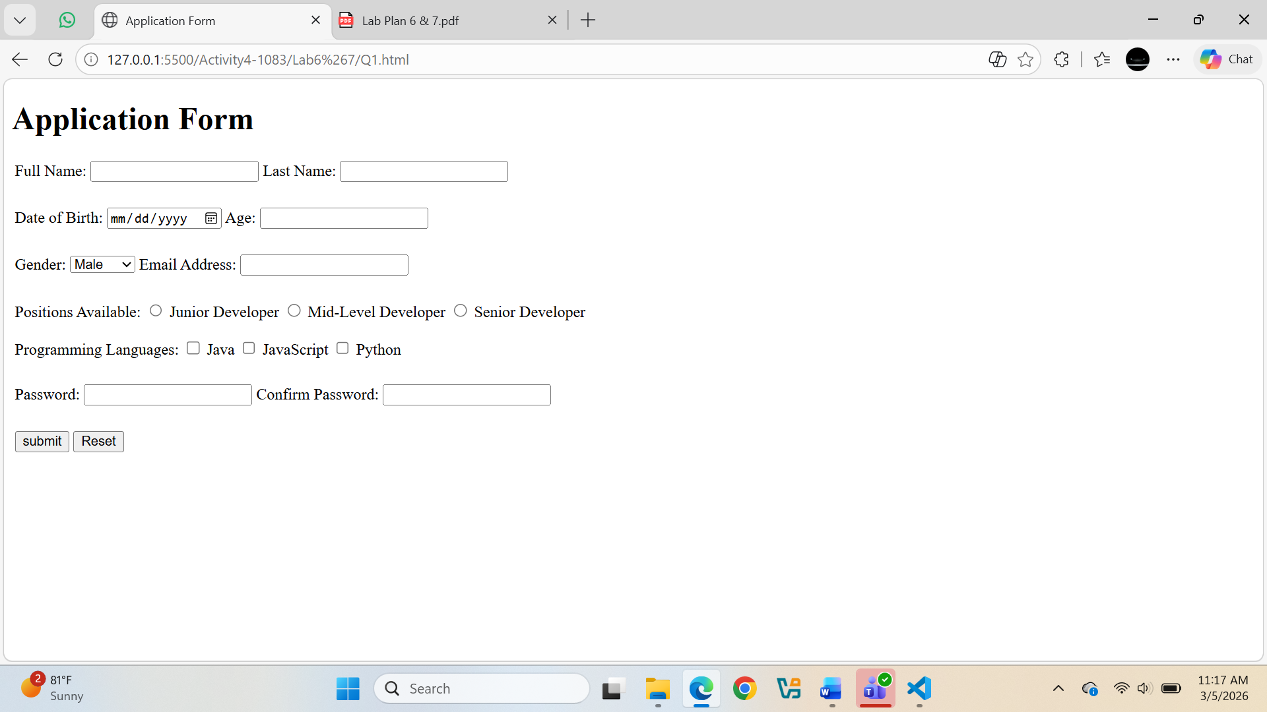
Question. No.2
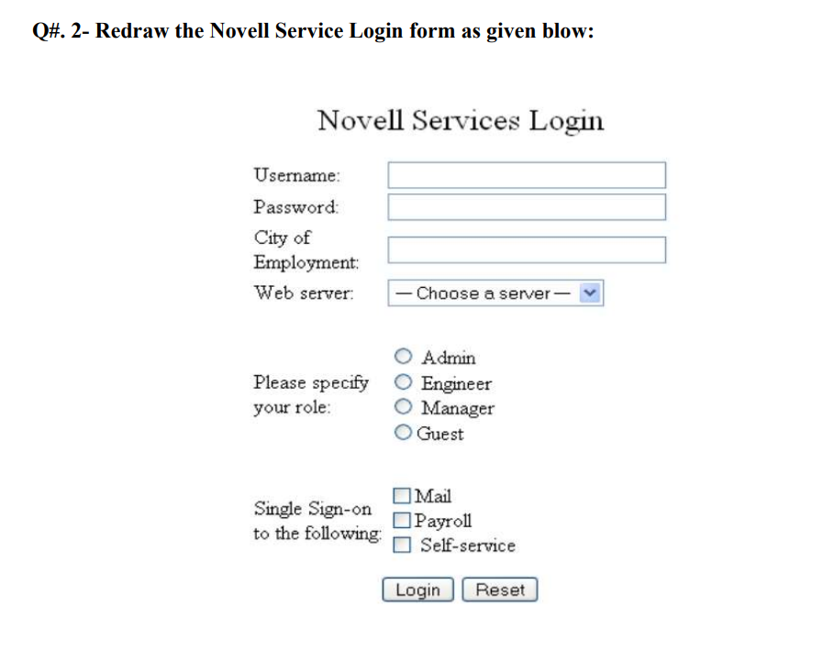

Code:
<!DOCTYPE html>
<html lang="en">
<head>
<meta charset="UTF-8">
<title>Document</title>
</head>
<body align="center">
<form>
<table align="center"cellpadding="8">
<h>Novell Service Login</h>
<tr>
<br><br>
<td>Username</td>
<td>
<input type="text" name="username" />
</td>
</tr>
<tr>
<td>Password:</td>
<td><input type="password" name="password" /></td>
</tr>
<tr>
<td>City of Employment</td>
<td><input type="text" name="city_of_employment" /></td>
</tr>
<tr>
<td>Web Servers</td>
<td> <select name="Web_Servers">
<option value="select">Select a Web Server</option>
<option value="html">HTML</option>
<option value="php">PHP</option>
<option value="python">Python</option>
</select>
</td>
</tr>
<tr>
<td>Please Specify your Role</td>
<td>
<input type="radio" name="role" value="Admin" /> Admin
<br>
<input type="radio" name="role" value="Engineer" /> Engineer
<br>
<input type="radio" name="role" value="Manager" /> Manager
<br>
<input type="radio" name="role" value="Guest" /> Guest
</td>
</tr>

<tr>
<td>Single sign on following</td>
<td>
<input type="checkbox" name="single_sign_on_following" value="mail" /> Mail
<br>
<input type="checkbox" name="single_sign_on_following" value="payrole" /> Payrole
<br>
<input type="checkbox" name="single_sign_on_following" value="self_service" /> Self Service
</td>
</tr>
</table>
<br><br>
<input style="width:auto;" type="submit" value="Login"/>
<input style="width:auto;" type="reset" value="Reset"/>

</form>

</body>
</html>
Output:
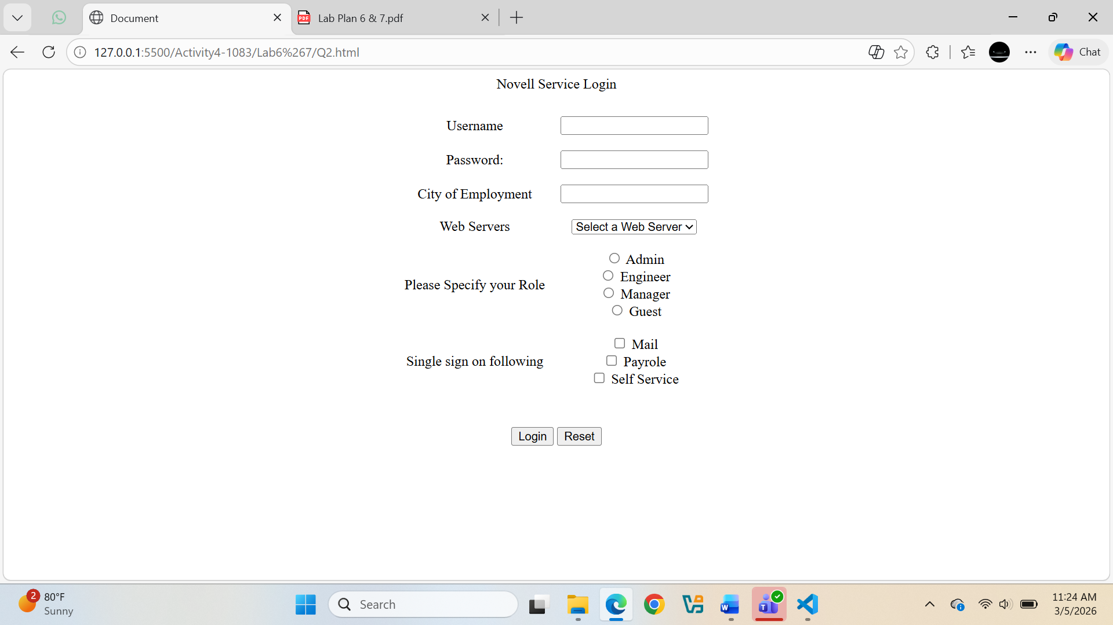
Question. No.3
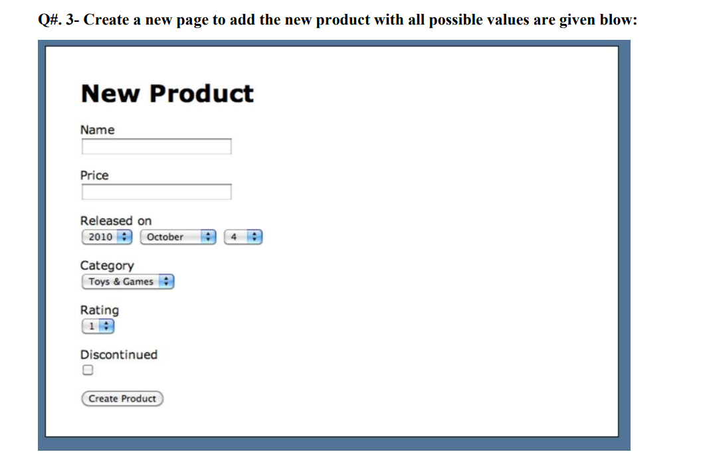
Code:
<!DOCTYPE html>
<html lang="en">
<head>
<meta charset="UTF-8">
<meta name="viewport" content="width=device-width, initial-scale=1.0">
<title>Document</title>
</head>
<body style="border: 10px solid rgb(94, 108, 151)">
<form>
<table >
<h1>New Product</h1>
<tr>
<td>Name
</td>
</tr>
<tr>
<td>
<input type="text" name="Name" />
</td>
</tr>
<td>
<br>
</td>
<tr>
<td>
Price
</td>
</tr>
<tr>
</tr>
<tr>
<td>
<input type="text" name="price"/>
</td>
</tr>
<td>
<br>
</td>
<tr>
<td>
Released on:
</td>
</tr>
<tr>
<td>
<select id="year" name="year">
<option value="2010">2010</option>
<option value="2011">2011</option>
<option value="2012">2012</option>
<option value="2013">2013</option>
</select>
<select id="month" name="month">
<option value="October">October</option>
<option value="November">November</option>
<option value="December">December</option>
</select>
<select id="day" name="day">
<option value="4">4</option>
<option value="5">5</option>
<option value="6">6</option>
<option value="7">7</option>
<option value="8">8</option>
</select>
</td>
</tr>
<td>
<br>
</td>
<tr>
<td>Toys&Games</td>
</tr>
<tr>
<td>
<select name="">
<option value="select">Toy&Game</option>
<option value="board_game">Board Game</option>
<option value="puzzle">Puzzle</option>
<option value="doll">Doll</option>
</td>
</tr>
<td>
<br>
</td>
<tr>
<td>
Rating
</td>
</tr>
<tr>
<td>
<select name="rating">
<option value="1">1</option>
<option value="2">2</option>
<option value="3">3</option>
<option value="4">4</option>
<option value="5">5</option>
</select>
</td>
</tr>
<td>
<br>
</td>
<tr>
<td>
Disconnected
</td>
</tr>
<tr>
<td>
<input type="checkbox" name="disconnected" value="disconnected"/> Disconnected
</td>
</tr>
<td>
<br>
</td>
<tr>
<td>
<input type="submit" value="Create Product"/>
</td>
</tr>
</table>
</form>
</body>
</html>
Output:
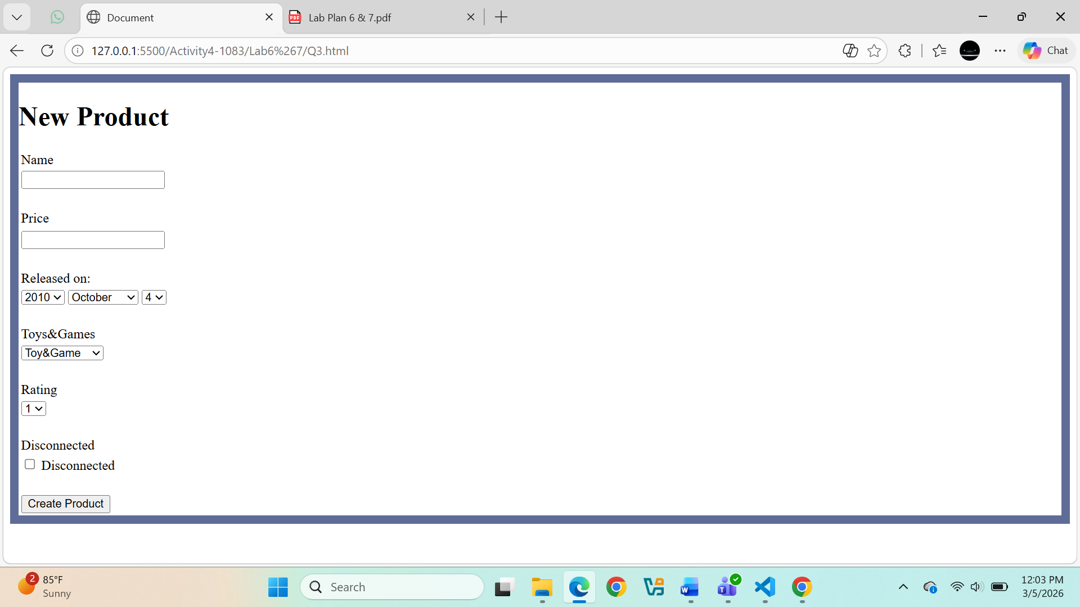
Question. No.4
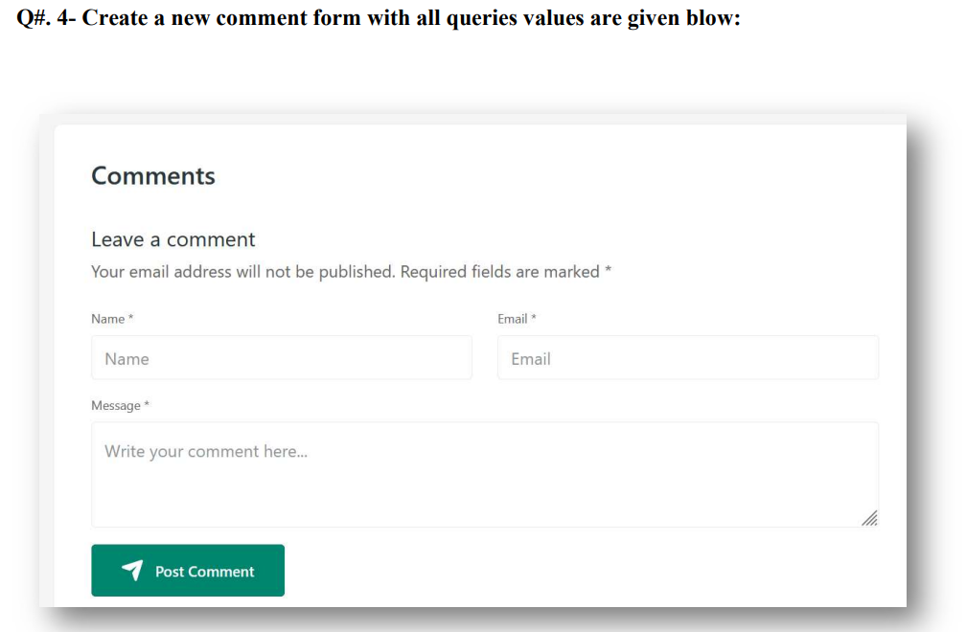
Code:
<!DOCTYPE html>
<html lang="en">
<head>
<meta charset="UTF-8">
<meta name="viewport" content="width=device-width, initial-scale=1.0">
<title>Document</title>
</head>
<body>
<form>
<table>
<h2>Comments</h2>
<br>
<h3>Leave a comment</h3>
Your email address will not be published. Required fields are marked *
<br><br>
<tr>
<td>
Name*
</td>
<td>
Email*
</td>
</tr>
<tr>
<td>
<input type="text" name="Name" value="Name"/>
</td>
<td>
<input type="email" name="Email" value="Email"/>
</td>
</tr>
<tr>
<td>
Message*
</td>
</tr>
<tr>
<td>
<textarea name="Message" rows="5" cols="50">
write your comment here.....
</textarea>
</td>
</tr>
<tr>
<td>
<div style="background-color: green; color: white; align-items: center;display: inline-block; padding: 10px;">
<img style="width: 20px;" src="Share.png"/>
<input type="submit" value="Post Comment" style="background: transparent; border: none; color: white; font-size: medium;" />

</div>
</td>
</tr>
</table>
</form>
</body>
</html>
Output:
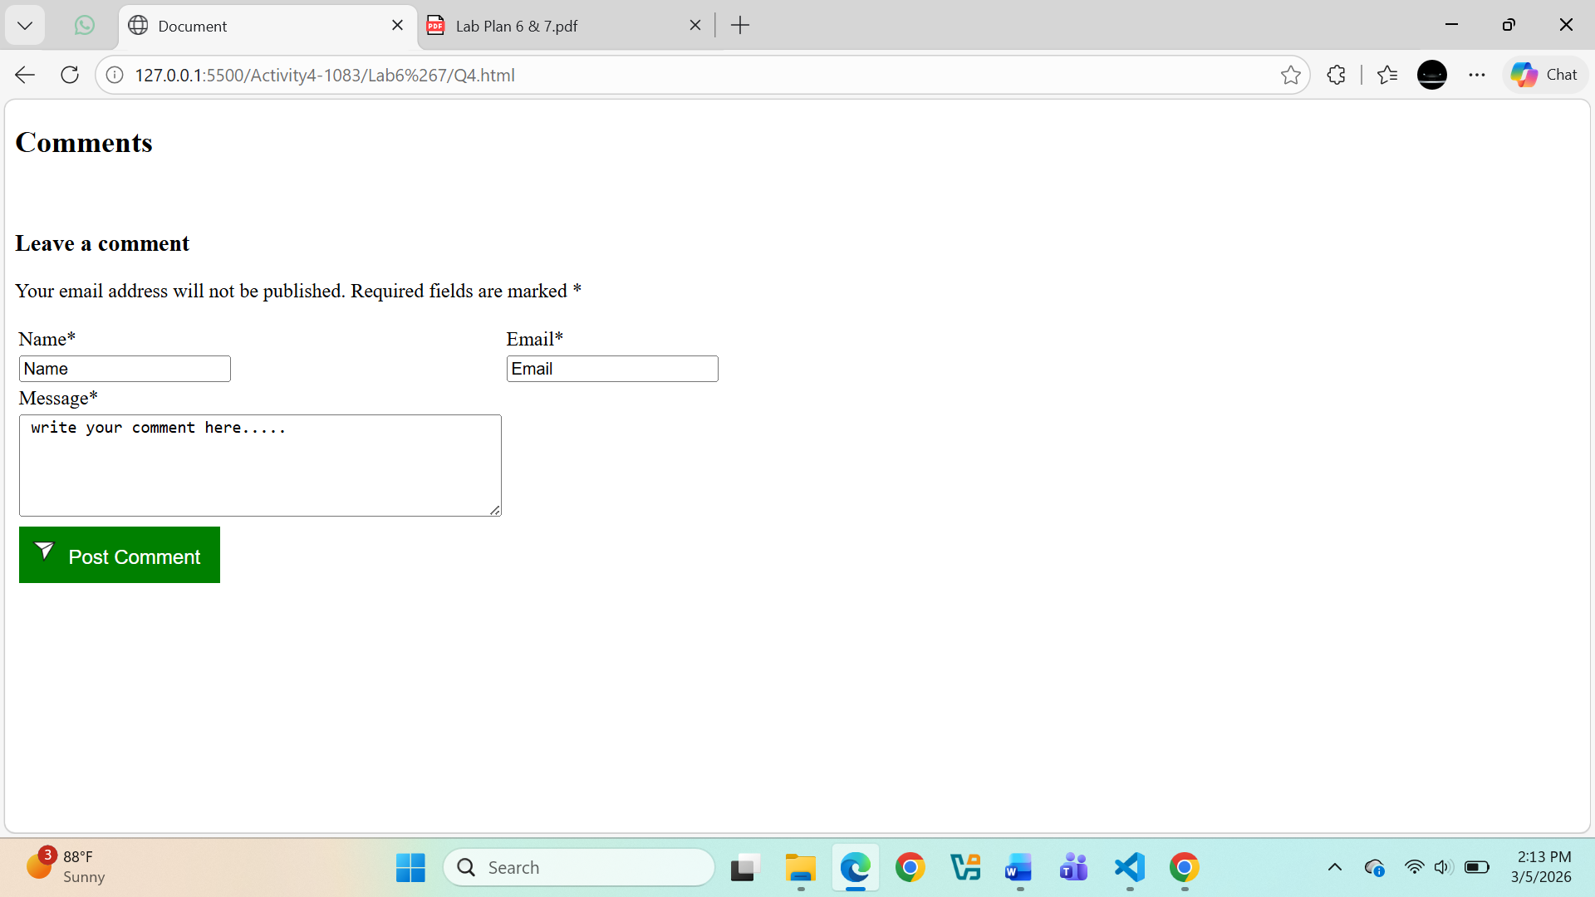
Question. No.5
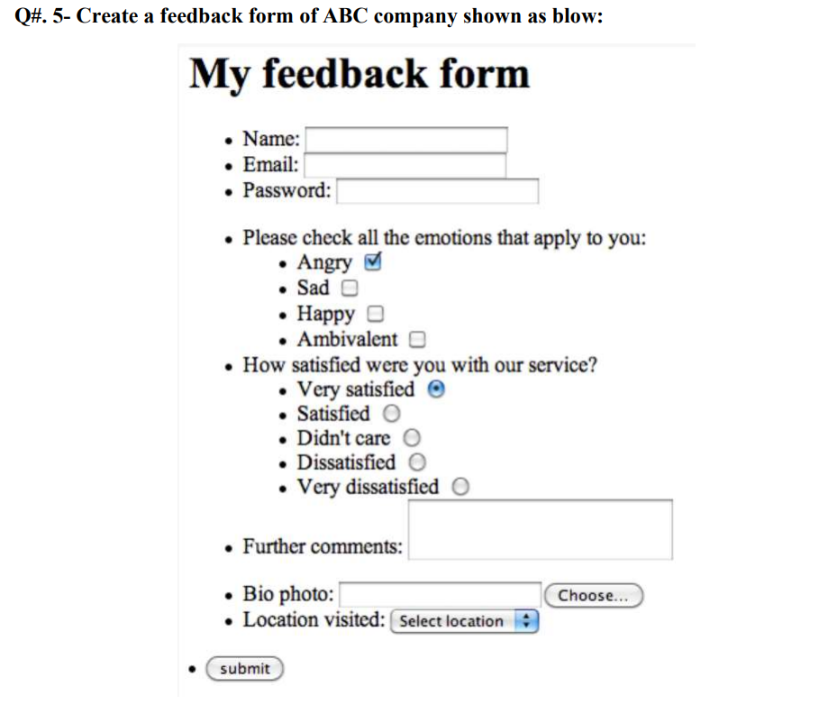
Code:
<!DOCTYPE html>
<html lang="en">
<head>
<meta charset="UTF-8">
<meta name="viewport" content="width=device-width, initial-scale=1.0">
<title>Document</title>
</head>
<body>
<form>
<table>
<h1> My Feedback Form </h1>
<tr>
<td>
<ul type="disc">
<ul type="disc">

<li>
Name:
<input type="text" name="Name"/>
</li>
<li>
Email:
<input type="email" name="Email"/>
</li>
<li>
Password:
<input type="password" name="Password"/>
</li>
<br>
<li>
Please check all the emotions that apply you:
</li>
<ul type="disc">
<li> Happy<input type="checkbox" name="Happy"/> </li>
<li> Sad<input type="checkbox" name="Sad"/> </li>
<li> Angry<input type="checkbox" name="Angry"/> </li>
<li> Ambivalent<input type="checkbox" name="Ambivalent"/> </li>
</ul>
<li>
How stisfied were you with our service?
</li>
<ul type="disc">
<li>
Very satisfied<input type="radio" name="verysatisfied"/>
</li>
<li>
Satisfied<input type="radio" name="satisfied"/>
</li>
<li>
Didn't care<input type="radio" name="didntcare"/>
</li>
<li>
Dissatisfied<input type="radio" name="dissatisfied"/>
</li>
<li>
Very dissatisfied<input type="radio" name="verydissatisfied"/>
</ul>
<li>
Further comments:
<textarea name="comments" rows="4" cols="30">
</textarea>
</li>
<li>
Biophoto:
<input placeholder="" />
<input type="file"/>
</li>
<li>
Location Visited:
<select name="location">
<option value="select location">Select Location</option>
<option value="newyork">New York</option>
<option value="paris">Paris</option>
<option value="tokyo">Tokyo</option>
<option value="sydney">Sydney</option>
</select>
</ul>
<br>
<li>
<input type="submit" value="Submit"/>
</li>
</ul>
</td>
</tr>
</table>
</form>
</body>
</html>
Output:
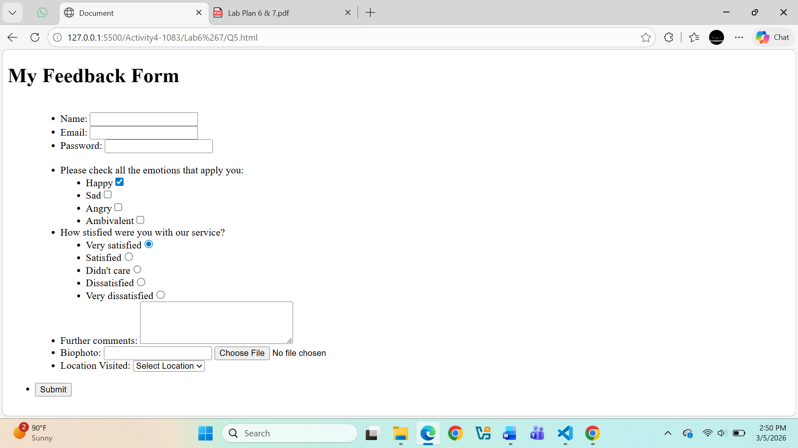
Question. No.6
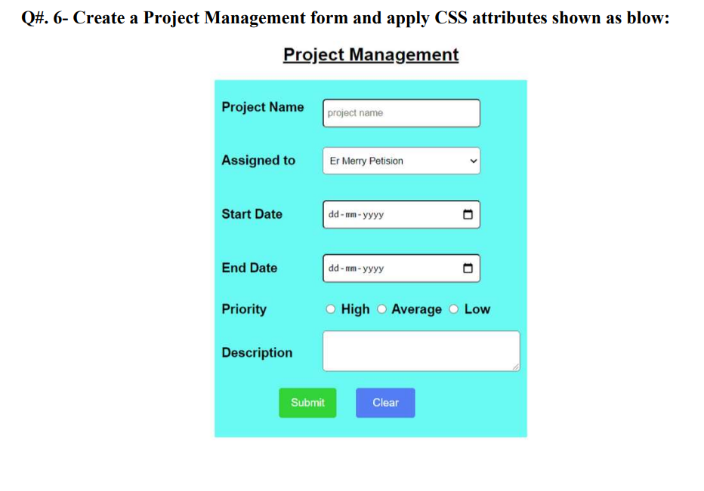
Code:
<!DOCTYPE html>
<html lang="en">
<head>
<meta charset="UTF-8">
<meta name="viewport" content="width=device-width, initial-scale=1.0">
<title>Document</title>
</head>
<body>
<u><h2 style="text-align: center;">Project Management</h2></u>
<form>
<table style="margin-left: auto; margin-right: auto;align-content: center; background-color: aqua;">
<tr>
<td>
Project Name
<input type="text" name="projectname"value="Project Name">
</td>
</tr>
<td>
<br>
</td>
<tr>
<td>
Assigned To:
<select name="assignedto">
<option value="Er Merry Petision">Er Merry Petision</option>
<option value="john">John</option>
<option value="michael">Michael</option>
<option value="sarah">Sarah</option>
</td>
</tr>
<td>
<br>
</td>
<tr>
<td>
Start Date:
<input type="date" name="startdate">
</td>
</tr>
<td>
<br>
</td>
<tr>
<td>
End Date:
<input type="date" name="enddate">
</td>
</tr>
<td>
<br>
</td>
<tr>
<td>
Priority:
<input type="radio" name="priority" value="high">High
<input type="radio" name="priority" value="medium">Average
<input type="radio" name="priority" value="low">Low
</td>
</tr>
<td>
<br>
</td>
<tr>
<td>
Description:
<textarea name="description" rows="4" cols="50"></textarea>
</td>
</tr>
<td>
<br>
</td>
<tr>
<td>
<div style="display: flex; justify-content: center; gap: 10px;">
<input style="background-color: rgb(6, 196, 133);width: 80px; color: aliceblue;" type="submit" value="Submit">
<input style="background-color:rgb(59, 111, 208);width: 80px; color: aliceblue;" type="reset" value="clear">
</div>
</td>
</table>
</form>
</body>
</html>
Output:
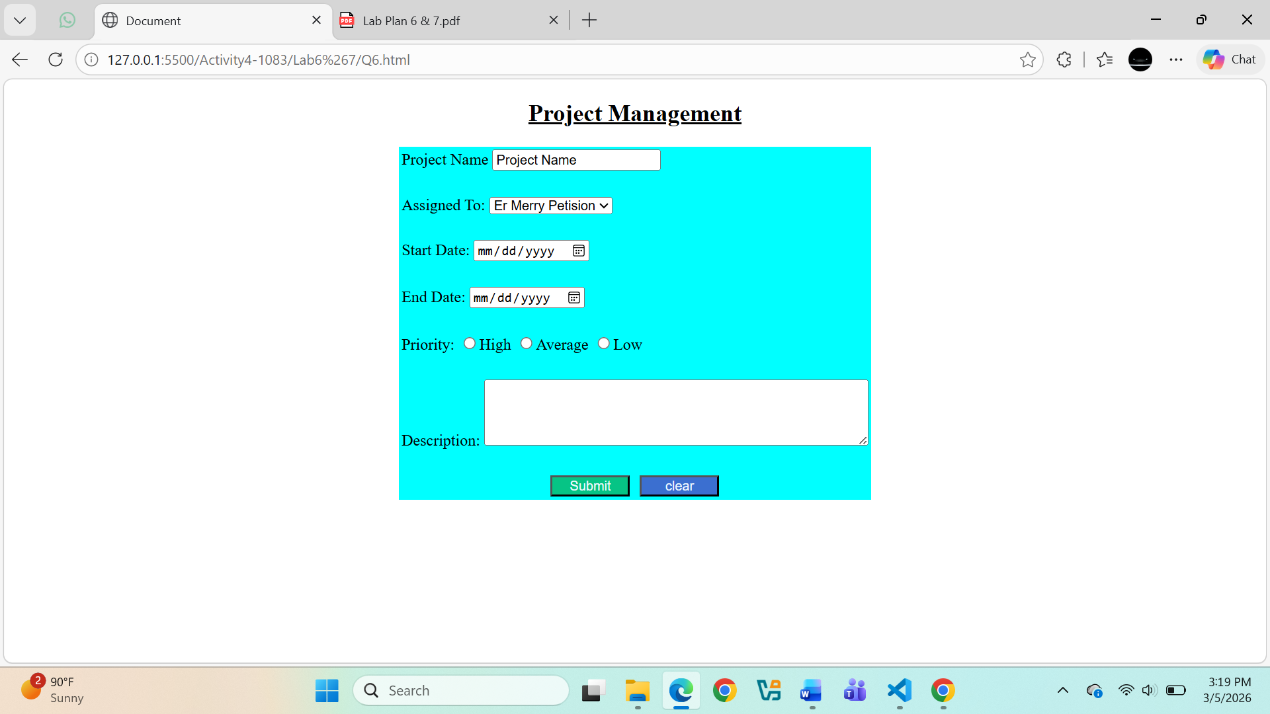
Question. No.7
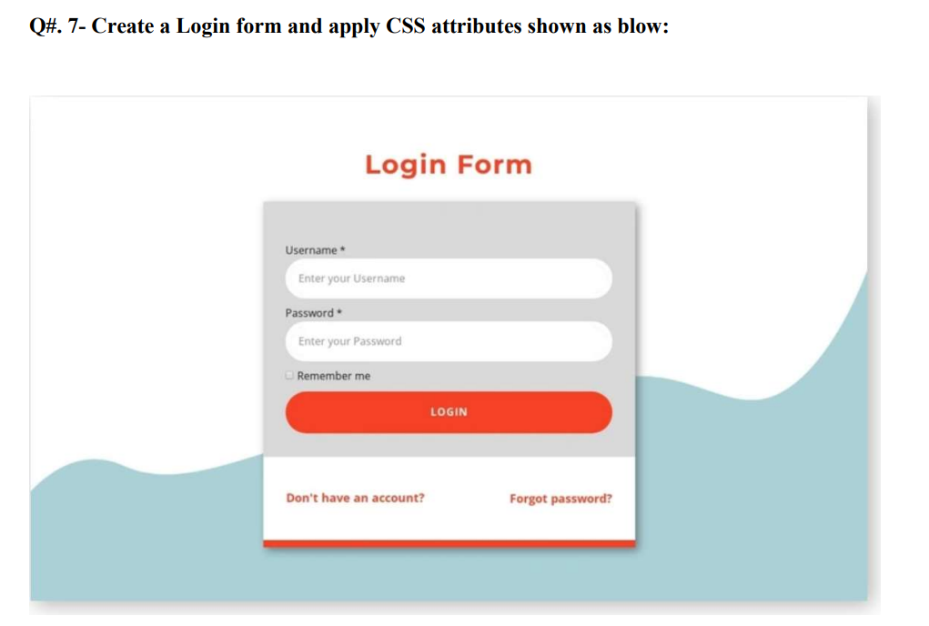
Code:
<!DOCTYPE html>
<html>
<head>
<title>Login Form</title>

<style>

body{
background:url("Background.jpg");
background-size:cover;
background-repeat:no-repeat;
background-position:center;
text-align:center;
font-family:Arial;
margin:0;
}

.box{
background:rgba(255,255,255,0.9);
width:300px;
margin:120px auto;
padding:20px;
border-radius:10px;
}

/* inputs */
input{
width:90%;
padding:8px;
margin:5px;
}

/* button */
button{
width:95%;
padding:10px;
background:orangered;
color:white;
border:none;
border-radius:20px;
}

/* links */
.links{
font-size:12px;
margin-top:10px;
}

</style>
</head>

<body>

<h2 style="color:orangered;">Login Form</h2>

<div class="box">

<form>

<label>Username</label><br>
<input type="text" placeholder="Enter your Username"><br><br>

<label>Password</label><br>
<input type="password" placeholder="Enter your Password"><br><br>

<input type="checkbox"> Remember me<br><br>

<button>LOGIN</button>

</form>

<div class="links">
<p>Don't have an account? | Forgot password?</p>
</div>
</div>
</body>
</html>
Output:
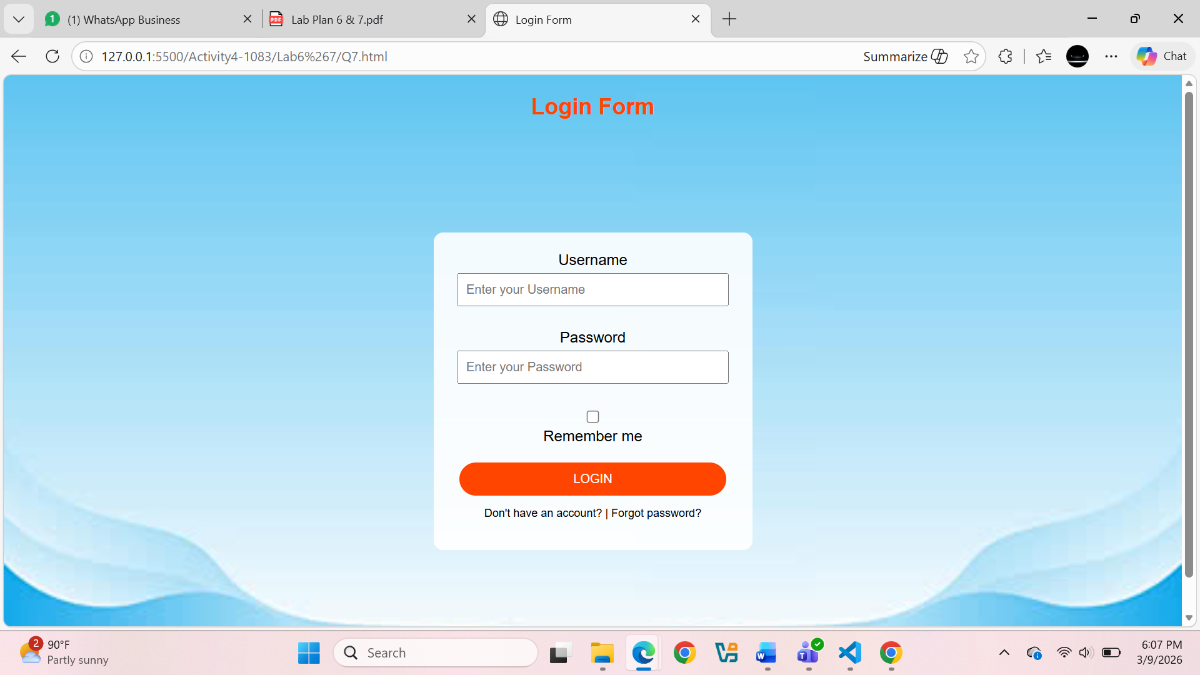
Question. No.8
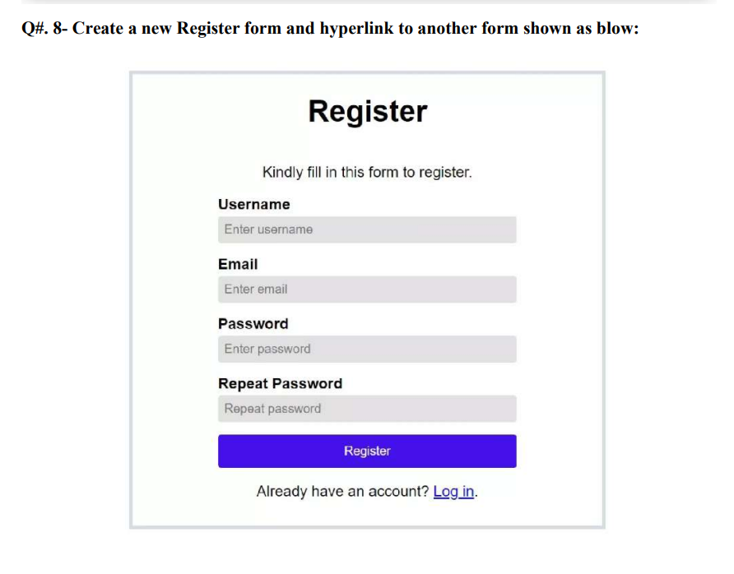
Code:
<!DOCTYPE html>
<html lang="en">
<head>
<meta charset="UTF-8">
<title>Document</title>
</head>
<body>
<form>
<table style="margin-left: auto; margin-right: auto;align-content: center;border: 5px solid gray; padding: 5%;">
<td>
<h1 style="text-align: center;"> Register </h1>
<p style="text-align: center;">kindly fil in this form to register</p>
</td>
<tr>
<td><b>Username</b></td>
</tr>
<tr>
<td>
<input style="background-color: rgb(173, 169, 169)" type="text" name="full_name" value="Enter username" />
</td>
<td>
<br><br>
</td>
</tr>
<tr>
<td><b>Email Address</b></td>
</tr>
<tr>
<td>
<input style="background-color: rgb(173, 169, 169)" type="text" name="email_address" value="Enter your email"/>
</td>
<td>
<br><br>
</td>
</tr>

<tr>
<td><b>Password</b></td>
</tr>
<tr>
<td><input style="background-color: rgb(173, 169, 169)"type="password" name="password" value="Enter your Password"/>
</td>
<td>
<br><br>
</td>
</tr>
<tr>
<td><b>Repeat Password</b></td>
</tr>
<tr>
<td><input style="background-color: rgb(173, 169, 169)"type="password" name="password" value="Repeat Password"/>
</td>
<td>
<br><br>
</td>
</tr>
<tr>
<td align="center">
<input style="background-color: blue; width: 100%; color: aliceblue;" type="submit" value="Register"/>
</td>
</tr>
<tr>
<td>
<br>
</td>
</tr>
<td style="text-align: center;">Already have an account? <u style="color:blue;">loginin</u></td>
</td>
</table>
</form>
</body>
</html>
Output:
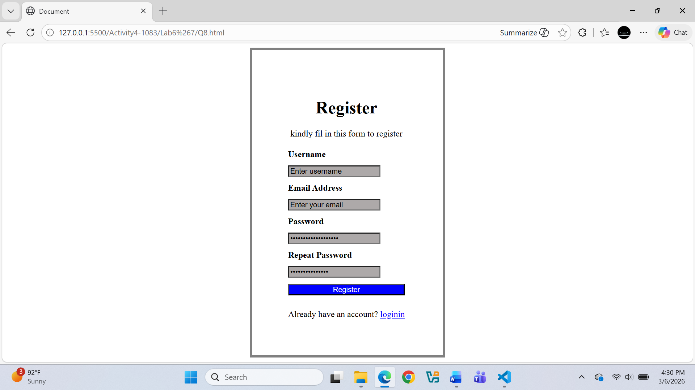
Question. No.9
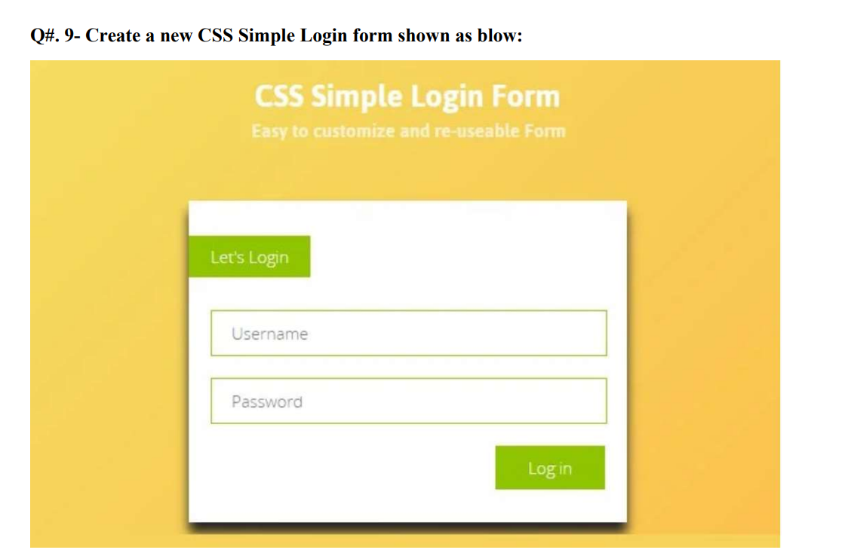
Code:
<!DOCTYPE html>
<html lang="en">
<head>
<meta charset="UTF-8">
<meta name="viewport" content="width=device-width, initial-scale=1.0">
<title>Document</title>
</head>
<body style="background-color:rgb(244, 188, 84); color: white;padding: 10px;">
<form>
<table style="margin-left: auto; margin-right: auto;align-content: center; background-color: white;width: 30%;">

<h1 style="text-align: center;">CSS Sample Login Form</h1>
<h2 style="text-align: center;">Easy to customize and reuseable Form</h2>
<td>
<br>
</td>
<tr>
<td>
<input style="background-color: rgb(203, 244, 79); border: none;width: 25%;height:40px;color:whitesmoke;" type="button" value="Let's Login"/>
</td>
</tr>
<td>
<br>
</td>
<tr>
<td>
<input style="border-color:rgb(206, 250, 76) ;width: 90%;height: 30px;margin-left: 10px;" type="text" name="full_name" value="Enter username" />
</td>
</tr>
<td>
<br>
</td>
<tr>
<td><input style="border-color:rgb(206, 250, 76);width: 90%;height: 30px;margin-left: 10px;" type="text" name="password" value="Enter your Password"/>
</td>
</tr>
<td>
<br>
</td>
<tr>
<td style="float:right">
<input style="background-color: rgb(203, 244, 79); border: none;width:100px;height:40px;color:whitesmoke;" type="button" value="Login"/>
</td>
</tr>
</table>
</form>
</body>
</html>
Output:
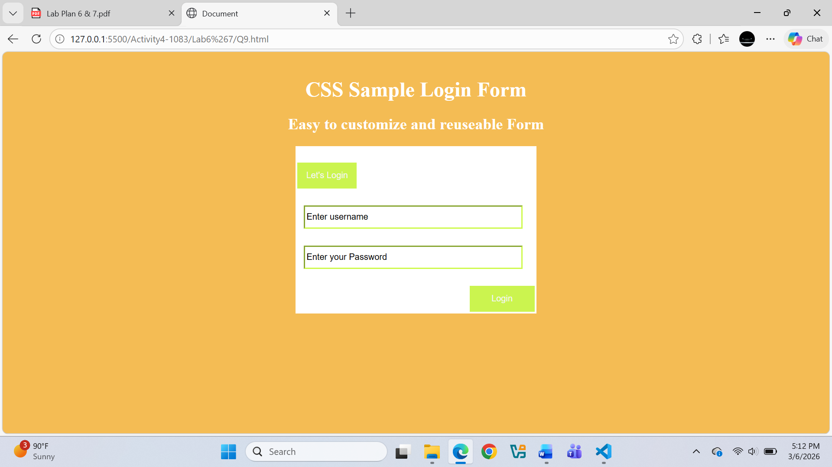

Question. No.10
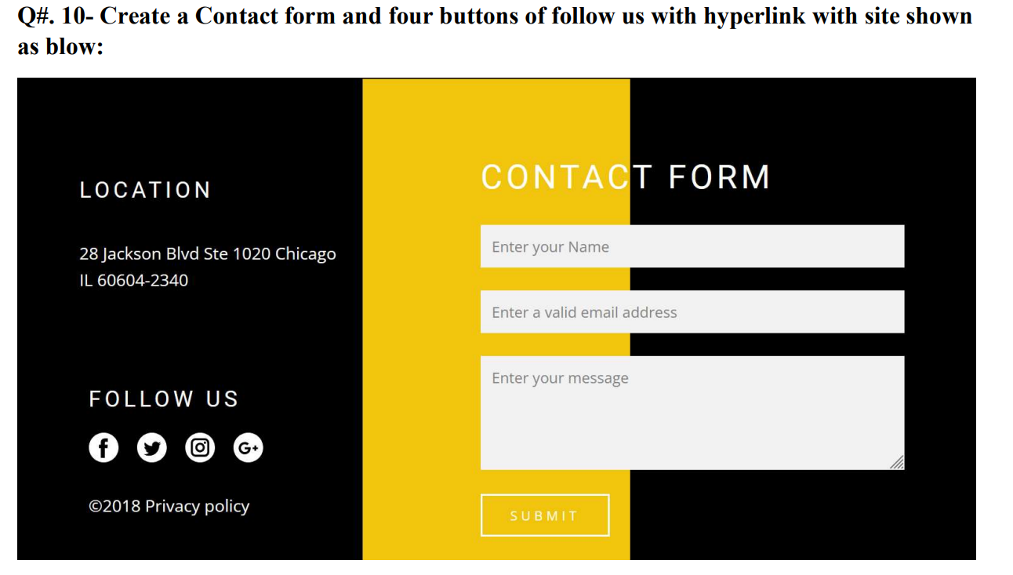
Code:
<!DOCTYPE html>
<html lang="en">
<head>
<meta charset="UTF-8">
<meta name="viewport" content="width=device-width, initial-scale=1.0">
<title>Document</title>
</head>
<body>

<div style="background-color:black;height: 600px; width:35%; float:left;color: white;">
<p style="margin-top:20%; text-align:center; font-size:xx-large;">Location</p>
<p style="margin-top:5%;text-align:center; font-size: large;">28 Jackson BLvd ste 1020 Chicago</p>
<p style="margin-top:5%;text-align: center; font-size: large;">IL 60604-2340</p>
<p style="margin-top:15%; text-align:center; font-size:xx-large;">Follow Us</p>
<img style="margin-top:5%;display:block; margin-left:auto; margin-right:auto;" src="logos.png" alt="facebook">
<p style="margin-top:5%;text-align:center; font-size: large;">&copy; 2018 Privacy Policy</p>
</div>
<div style="background-color:orange;height:600px;width:30%;float:left;"></div>

<div style="background-color:black;height:600px;width:35%;float:left;"></div>

<form style="margin-top:120px;margin-left:700px;color:white;position:absolute;">
<h1>Contact Form</h1>

<input style="width: 100%;height: 25px; border-color: rgb(189, 249, 229);" type="text" name="Name" value="Enter Your Name"><br><br>

<input style="width: 100%;height: 25px; border-color: rgb(189, 249, 229);" type="email" name="Email" value="Enter Your valid Email"><br><br>

<textarea style="border-color: rgb(189, 249, 229);" name="Message" rows="6" cols="40" placeholder="Enter Your Message"></textarea><br><br>

<input style="width: 30%;height: 25px; border-color: aliceblue;background-color:orange;color: white; font-size: larger;" type="submit" value="Submit">
</form>
</body>
</html>
Output:
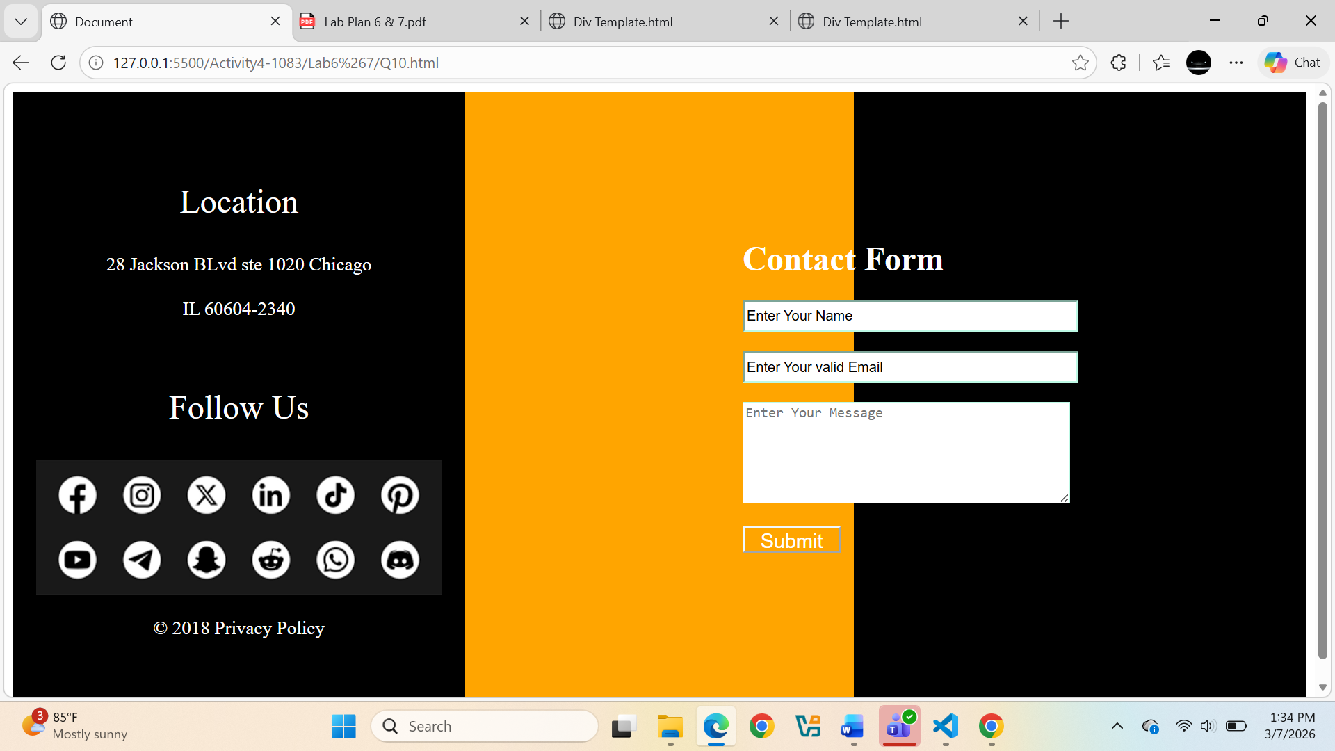
Question. No.11
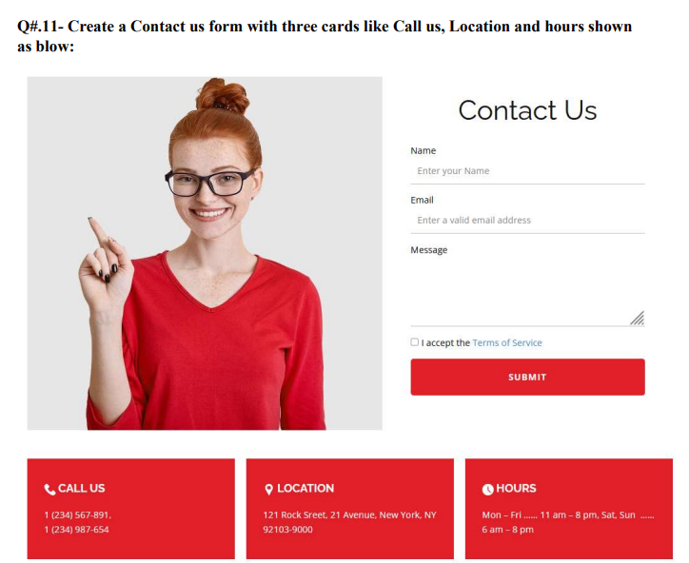
Code:
<!DOCTYPE html>
<html lang="en">
<head>
<meta charset="UTF-8">
<meta name="viewport" content="width=device-width, initial-scale=1.0">
<title>Document</title>
</head>
<body>
<header>
<div style="height:150px;width: 50px;float:left">
<img style="width: fit-content;" src="Girl.jpg"/>
</div>

<div>
<form style="margin-left:600px;color:Black;">
<h1>Contact US</h1>
Name:<br>
<input style="width:50%; height:25px; border:none; border-bottom:2px solid black; outline:none;" type="text" name="Name" value="Enter Your Name"><br><br>
Email:<br>
<input style="width: 50%;height: 25px; border:none; border-bottom:2px solid black; outline:none;" type="email" name="Email" value="Enter Your valid Email"><br><br>
Message:<br>
<textarea style="border:none; border-bottom:2px solid black; outline:none;" name="Message" rows="6" cols="40" placeholder="Enter Your Message"></textarea><br><br>
<input type="checkbox"value="I agree to the terms and conditions"> I agree to the terms and conditions<br><br>
<input style="width: 70%;height: 45px; border-color:RED;background-color:RED;color: white; font-size: larger;" type="submit" value="Submit">
</div>
<div style="clear:both;"></div>
</header>
<section style=" height: 120px; text-align:center;">
</section>
<footer style=" text-align:center; color:white">
<div style="display:inline-block; width:25%;background-color:Red;">
<img src="Phone.jpg" width="30">
<p style="font-size: x-large;font-weight: bold;display:inline-block ">Call Us</p>
<p style="font-size:medium;">1(234)567891</p>
<p style="font-size:medium;">1(234)987654</p>
</div>

<div style="display:inline-block; width:25%; background-color:Red;">
<img src="Location.jpg" width="30">
<p style="font-size: x-large; font-weight: bold;display:inline-block">Location</p>
<p style="font-size:medium;">121 Rock Street, 21 Avenue, NewYork, Ny</p>
<p style="font-size:medium;">92103-90000</p>
</div>

<div style="display:inline-block; width:25%; background-color:Red; ">

<img src="Clock.jpg" width="30">
<p style="font-size: x-large; font-weight: bold; display:inline-block">Hours</p>
<p style="font-size:medium;">Mon-Fri.....11am-8pm,Sat,Sun......</p>
<p style="font-size:medium;">6pm-8pm</p>
</footer>
</form>
</body>
</html>
Output:
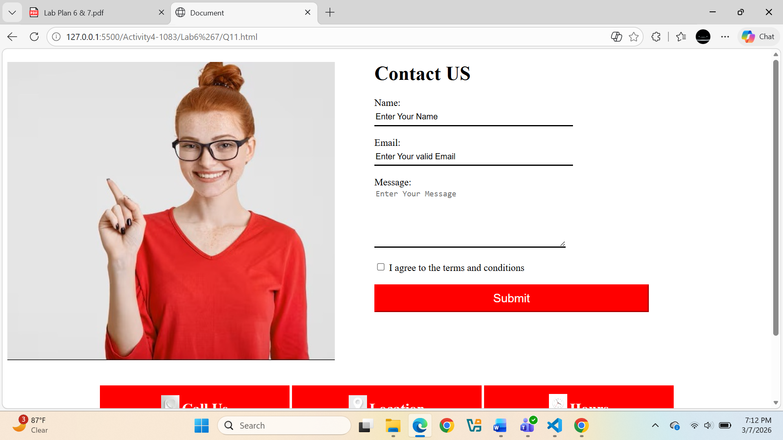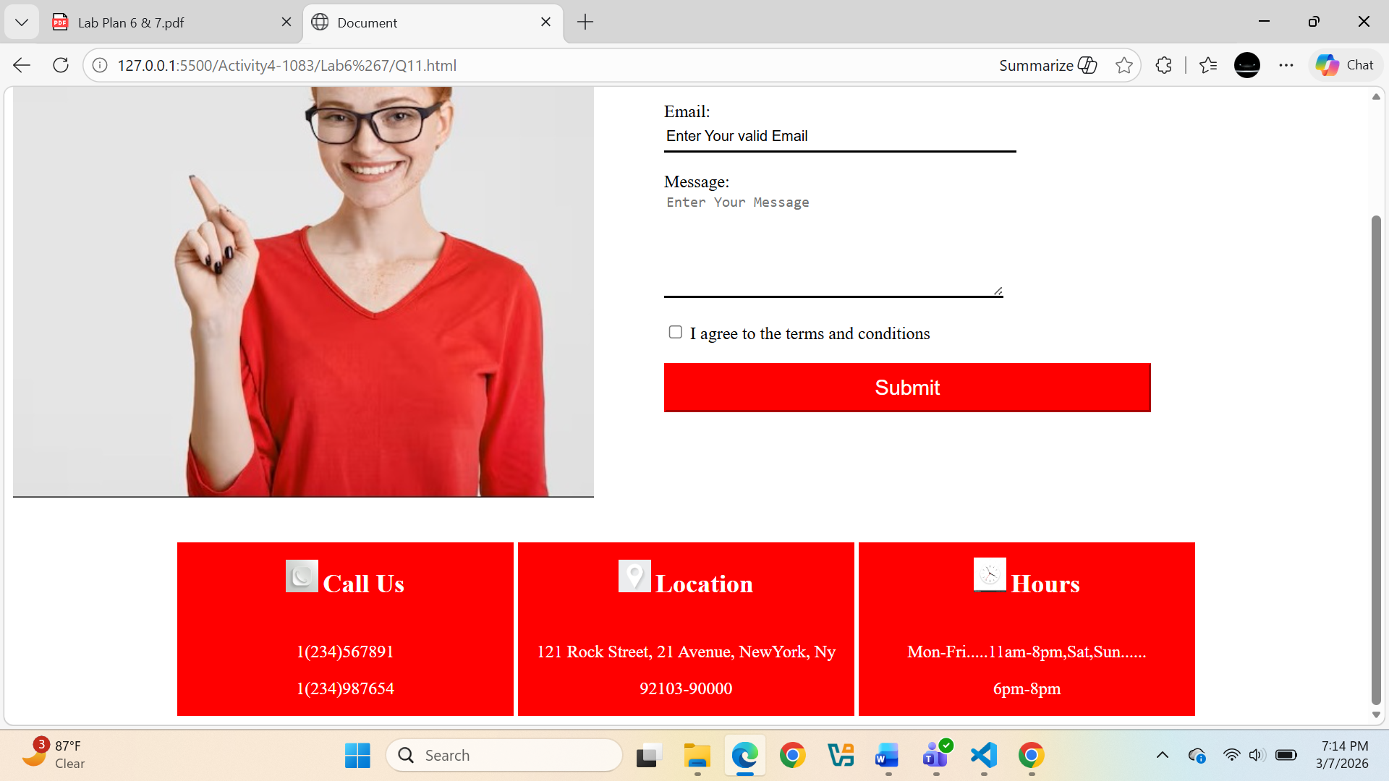
Question. No.12
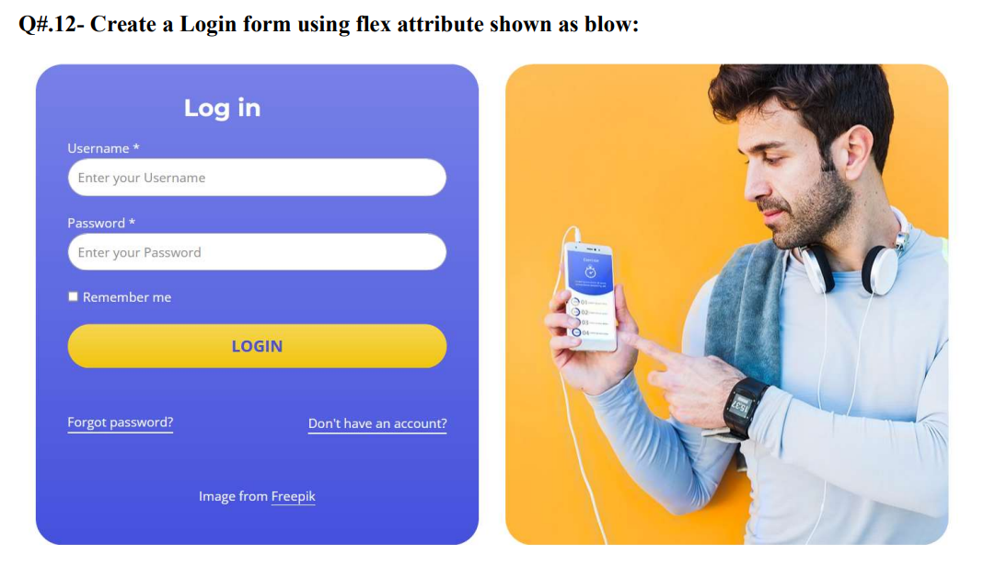
Code:
<!DOCTYPE html>
<html lang="en">
<head>
<meta charset="UTF-8">
<meta name="viewport" content="width=device-width, initial-scale=1.0">
<title>Document</title>
</head>
<body>
<form>
<div>
<img style="width:50%;height: 10%; float:right" src="Boy.jpg"/>
</div>
<div style="width:46%;height:630px; float:left; background-color: rgb(44, 44, 173);color:white;">
<h1 style="margin-top: 20px;text-align:center;">Log In</h1>
<p style="margin-left: 20px;">username*</p>
<input style="width: 80%;height: 25px;margin-left: 20px; border-color: white; background-color: transparent; color:white;" type="text" name="username" value="Enter Your Username"><br>
<p style="margin-left: 20px;">password*</p>
<input style="width: 80%;height: 25px;margin-left: 20px; border-color: white; background-color: transparent; color:white;" type="text" name="password" value="Enter Your Password"><br>
<br>
<input style="margin-left: 20px;" type="checkbox" value="Remember me"/> Remember me<br>
<br>
<input style="width: 80%;height: 30px;margin-left: 20px; border-color: white; background-color:yellow; color:rgb(9, 9, 108);" type="submit" value="Login">
<br>
<p style="float: left; "><a style="color: white; background-color: transparent; " href="#">Forget Password? </a></p>
<p style="float: right; "><a style="color: white; background-color: transparent; " href="#">Don't have an account? </a></p>
<br>
<p style="margin-top: 95px;text-align: center;">IMage from Freepik</p>
</div>
</form>
</body>
</html>
Output:
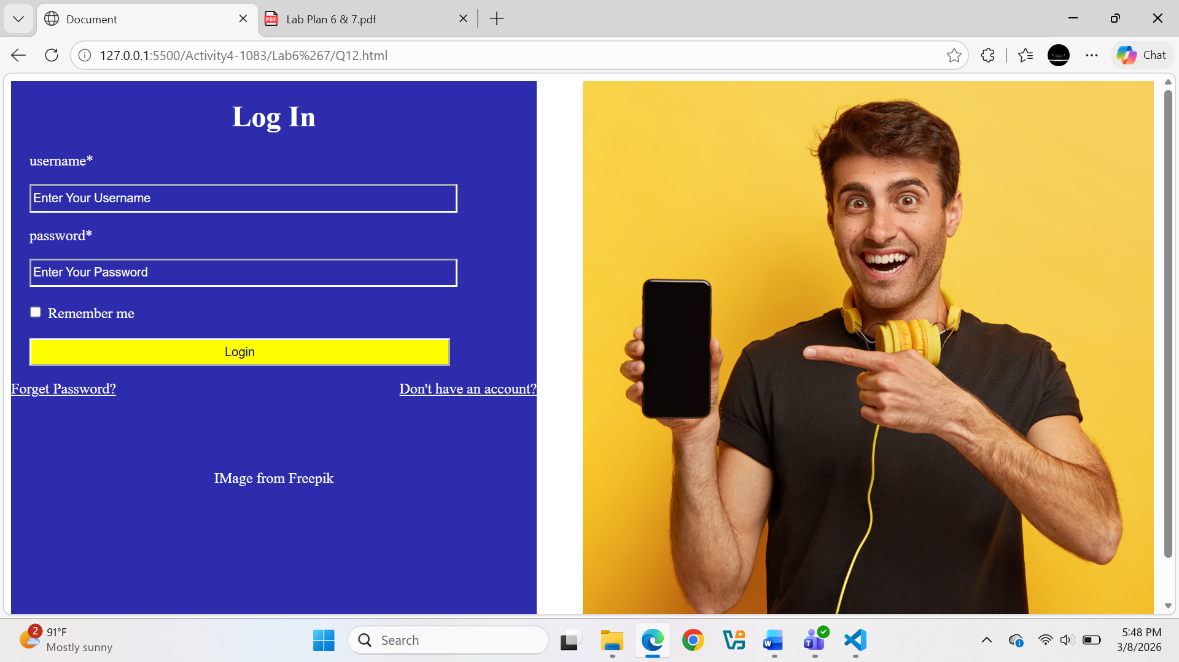
Question. No.13
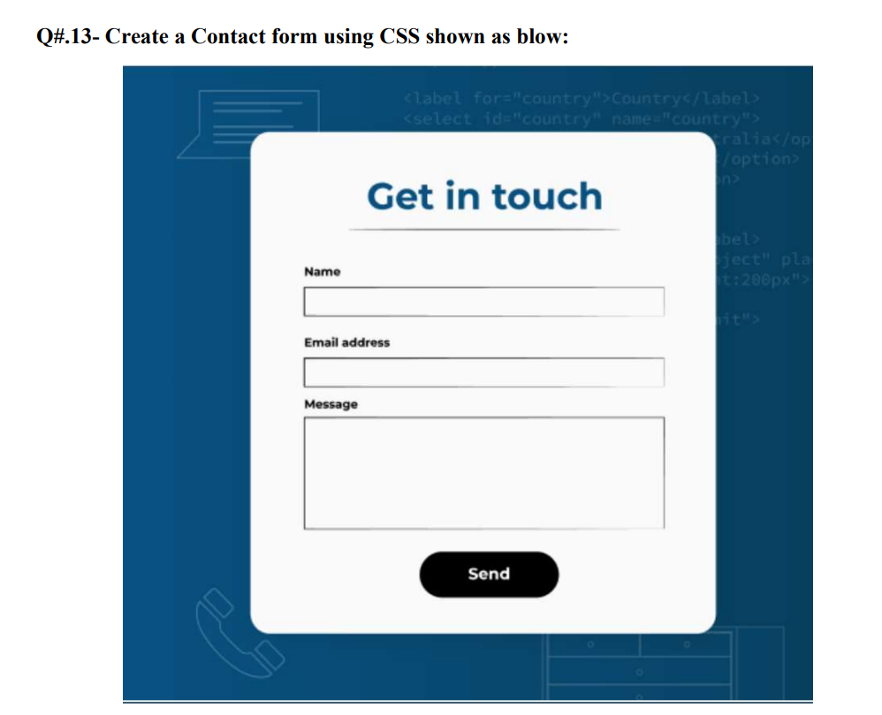
Code:
<!DOCTYPE html>
<html lang="en">
<head>
<meta charset="UTF-8">
<meta name="viewport" content="width=device-width, initial-scale=1.0">
<title>Document</title>
</head>
<body style="background-image: url('Contact\ Us.jpg'); background-size: cover; background-repeat: no-repeat;">
<form>
<table style="background-color: white;margin-left: auto; margin-right: auto;align-content: center;color: black;font-size: large; margin-top: 80px;">
<br>
<td>
<h1 style="text-align: center; color:navy"><u>Get in touch</u></h1>
</td>
<tr>
<td>
Name
</td>
</tr>
<tr>
<td>
<input type="text" name="Name"/>
</td>
</tr>
<tr>
<td>
Email
</td>
</tr>
<tr>
<td>
<input type="email" name="Email" />
</td>
</tr>
<tr>
<td>
Message*
</td>
</tr>
<tr>
<td>
<textarea name="Message" rows="5" cols="50">
</textarea>
</td>
</tr>
<tr>
<td>
<div style="background-color: black;color:white;margin-left:150px; display: inline-block; padding: 10px;">
<input style="background: transparent; border: none; color: white; font-size: medium;" type="submit" value="Send"/>
</div>
</td>
</tr>
</table>
</form>
</body>
</html>
Output:
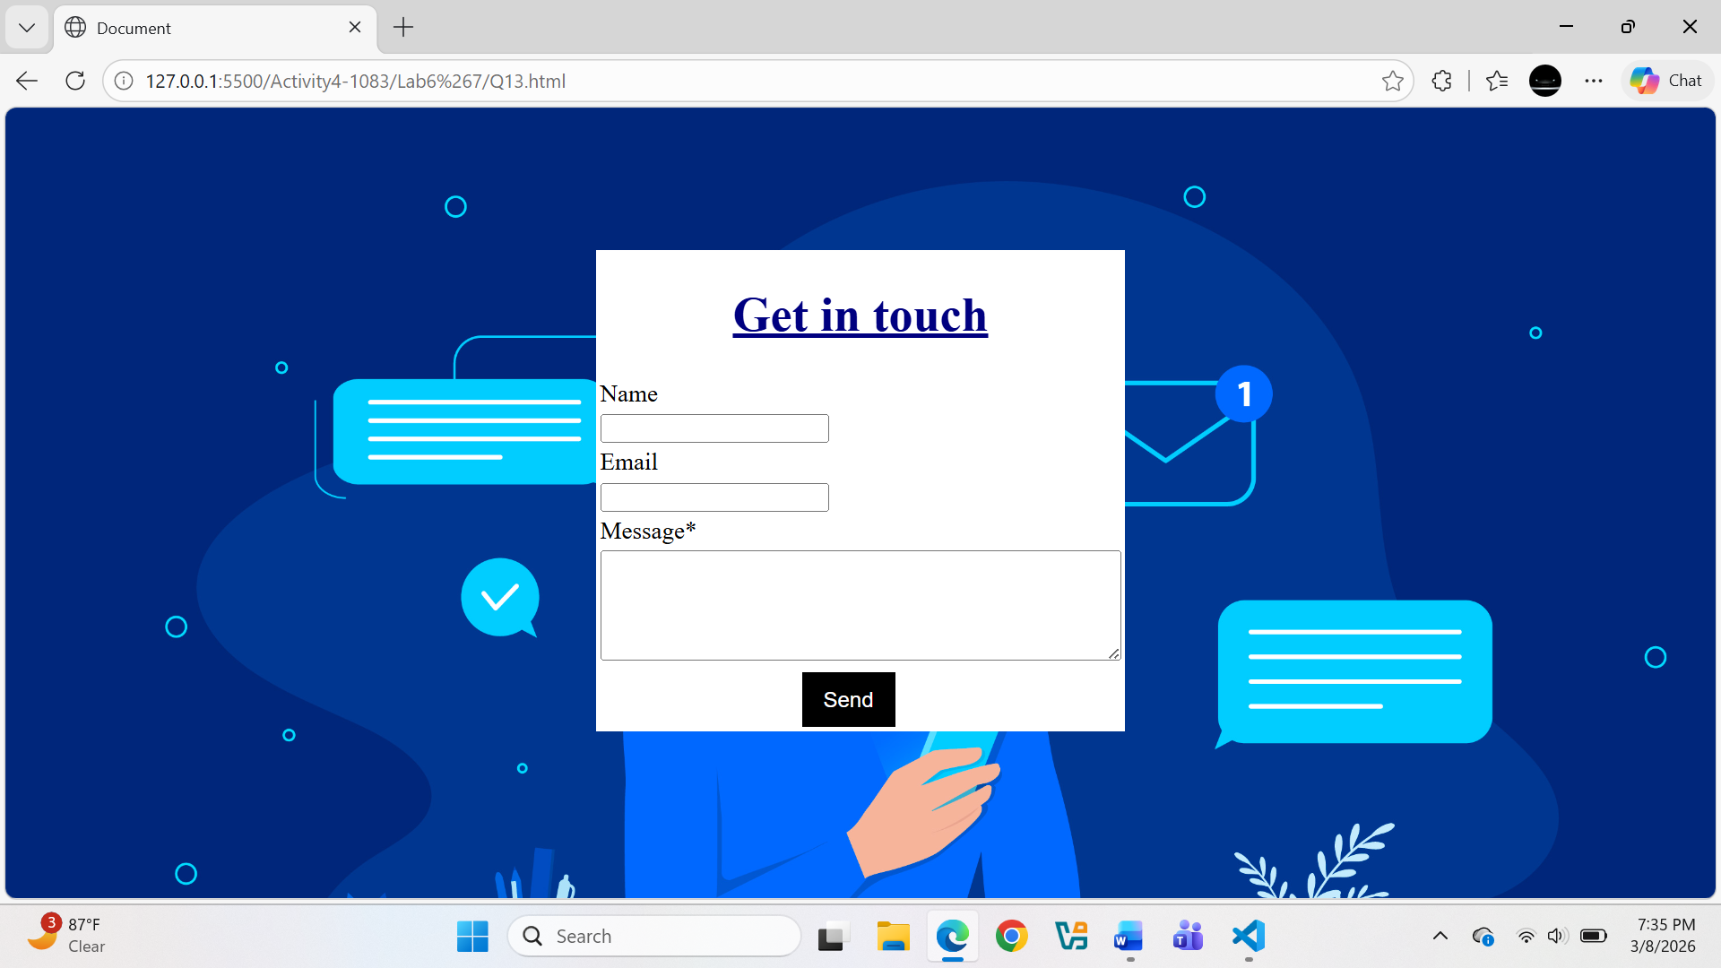
Question. No.14
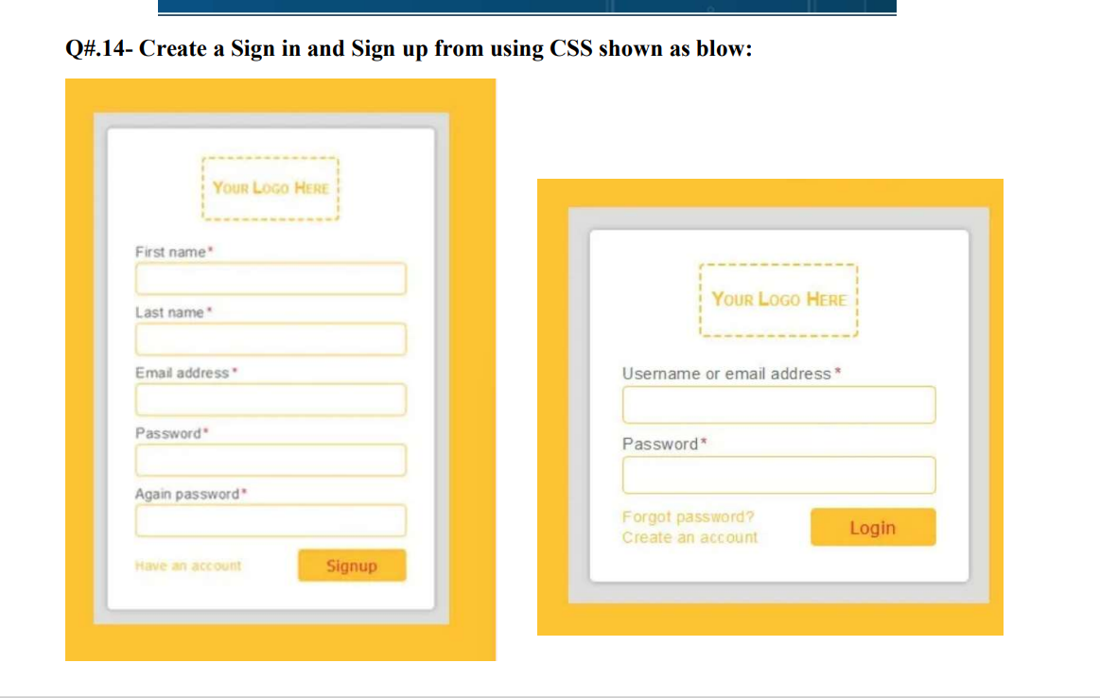
Code:
<!DOCTYPE html>
<html>
<head>
<title>Signup / Login</title>
</head>

<body style="font-family:Arial; background:white;">

<!-- SIGNUP FORM (LEFT - BIG) -->
<div style="background:#f2b632;padding:30px;display:inline-block;margin:30px;">
<div style="width:320px;background:#eee;padding:20px;border-radius:5px;">

<h3 style="text-align:center;border:2px dashed #f2b632;padding:10px;">Your Logo Here</h3>

<p>First name *</p>
<input type="text" style="width:100%;height:30px;border:1px solid #f2b632;">

<p>Last name *</p>
<input type="text" style="width:100%;height:30px;border:1px solid #f2b632;">

<p>Email address *</p>
<input type="text" style="width:100%;height:30px;border:1px solid #f2b632;">

<p>Password *</p>
<input type="password" style="width:100%;height:30px;border:1px solid #f2b632;">

<p>Again password *</p>
<input type="password" style="width:100%;height:30px;border:1px solid #f2b632;">

<br><br>

<span style="color:#f2b632;">Have an account</span>

<input type="button" value="Signup"
style="float:right;background:#f2b632;border:none;padding:10px 20px;color:white;">

</div>
</div>

<!-- LOGIN FORM (RIGHT - SMALL) -->
<div style="background:#f2b632;padding:30px;display:inline-block;margin:30px;">
<div style="width:320px;background:#eee;padding:20px;border-radius:5px;">

<h3 style="text-align:center;border:2px dashed #f2b632;padding:10px;">Your Logo Here</h3>

<p>Username or email address *</p>
<input type="text" style="width:100%;height:30px;border:1px solid #f2b632;">

<p>Password *</p>
<input type="password" style="width:100%;height:30px;border:1px solid #f2b632;">

<br><br>

<span style="color:#f2b632;">Forgot password?<br>Create an account</span>

<input type="button" value="Login"
style="float:right;background:#f2b632;border:none;padding:10px 20px;color:white;">

</div>
</div>

</body>
</html>
Output:
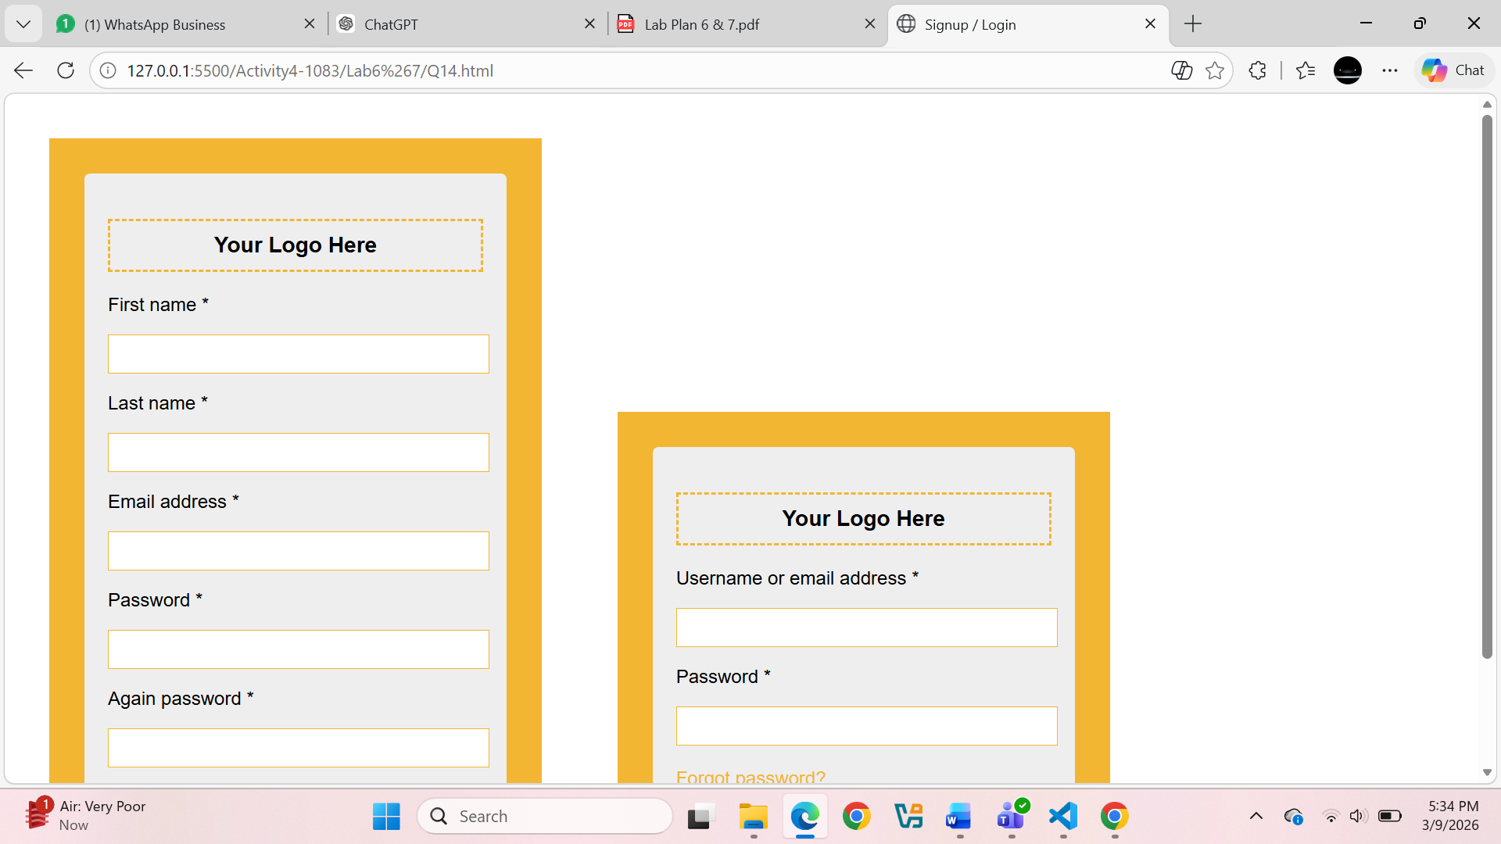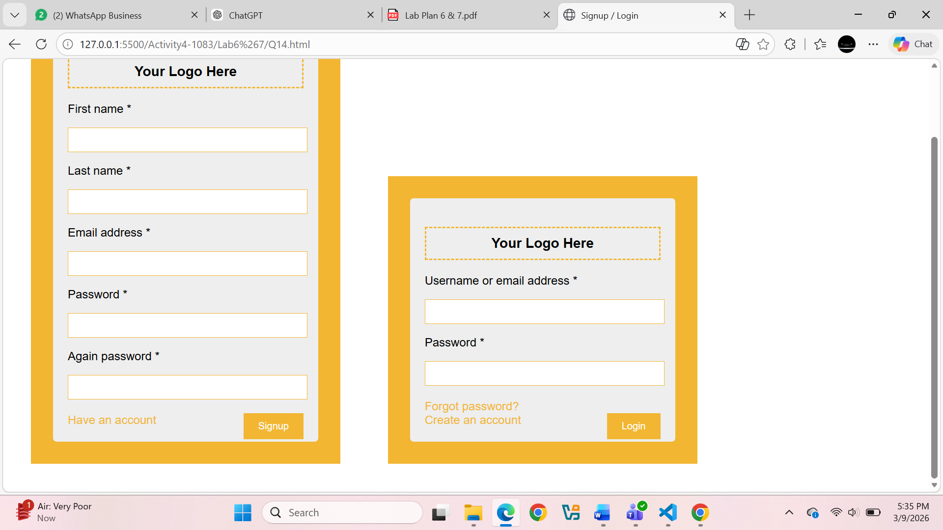
Question. No.15

Code:
<!DOCTYPE html>
<html>
<head>
<title>Contact Us</title>

<style>
body{
margin:0;
font-family:Arial;
background:linear-gradient(90deg,#6a3dd9,#5b2bd1);
}

.top{
position:relative;
text-align:center;
padding-top:60px;
}

/* yellow circles */
.circle1{
position:absolute;
width:220px;
height:220px;
background:#f7b733;
border-radius:50%;
top:100px;
left:30%;
z-index:0;
}

.circle2{
position:absolute;
width:220px;
height:220px;
background:#f7b733;
border-radius:50%;
top:80px;
left:55%;
z-index:0;
}

/* image */
.top img{
width:250px;
height:250px;
border-radius:50%;
position:relative;
z-index:1;
object-fit:cover;
}

.container{
width:800px;
margin:40px auto;
background:#eee;
display:flex;
}

.left{
width:50%;
padding:30px;
}

.right{
width:50%;
padding:30px;
background:#ddd;
text-align:center;
}

.left h2{
color:#6a3dd9;
}

input,textarea{
width:100%;
border:none;
border-bottom:2px solid #6a3dd9;
margin:10px 0;
padding:8px;
}

button{
width:100%;
padding:10px;
background:#6a3dd9;
color:white;
border:none;
border-radius:5px;
}

.right h4{
color:#6a3dd9;
}

</style>
</head>

<body>

<div class="top">

<div class="circle1"></div>
<div class="circle2"></div>

<img src="Scholar.jpg">

</div>

<div class="container">

<div class="left">
<h2>Contact Us</h2>

Name
<input type="text" placeholder="Enter your name">

Email
<input type="email" placeholder="Enter a valid email address">

Message
<textarea rows="4"></textarea>

<br>
<input type="checkbox"> I accept the Terms of Service
<br><br>

<button>SUBMIT</button>
</div>

<div class="right">

<h4>CALL US</h4>
<p>1 (234) 567-891<br>1 (234) 987-654</p>

<h4>LOCATION</h4>
<p>121 Rock Street, 21 Avenue,<br>New York, NY</p>

<h4>OUR TOP SERVICES</h4>
<p>Self-Studying<br>Online Courses<br>Challenge Yourself</p>
</div>
</div>
</body>
</html>
Output:
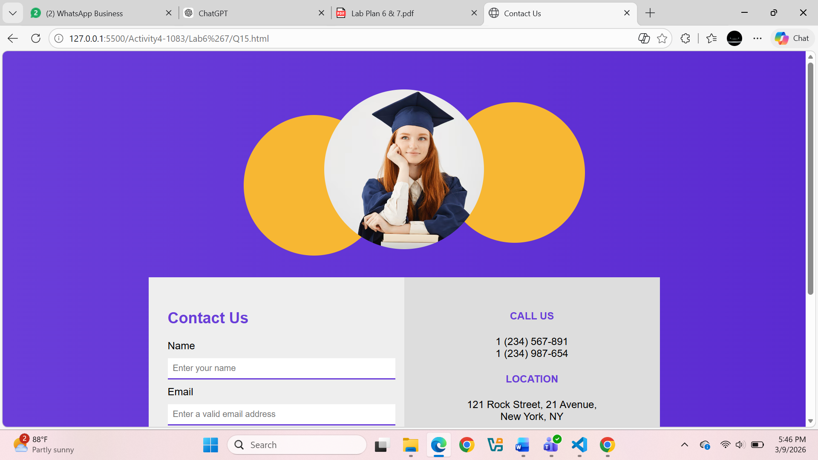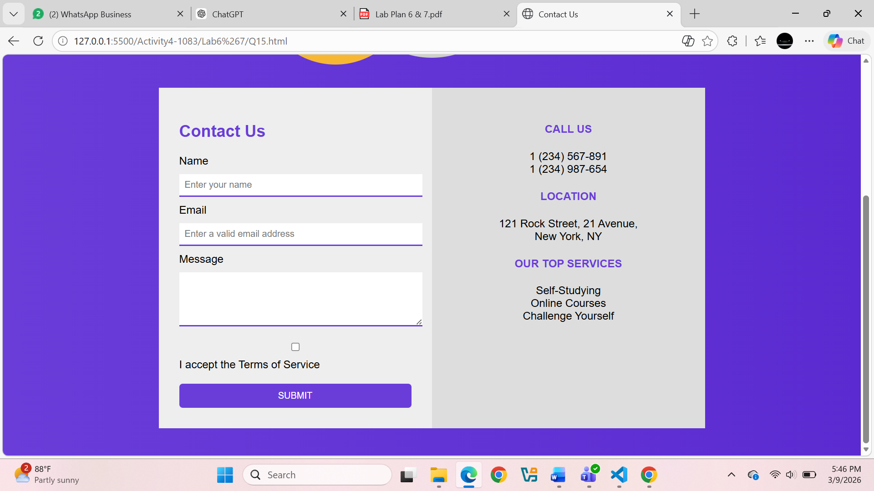
Question. No.16
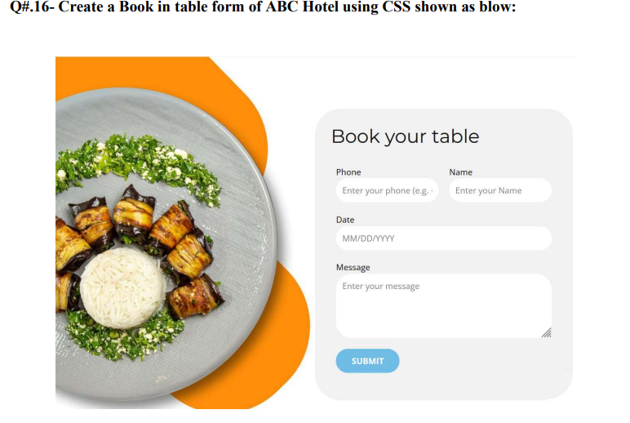
Code:
<!DOCTYPE html>
<html lang="en">
<head>
<meta charset="UTF-8">
<title>ABC Hotel Booking</title>
<style>
body {
font-family: 'Arial', sans-serif;
background-color: #d8d1cd;
margin: 0;
display: flex;
align-items: center;
justify-content: center;
min-height: 100vh;
}

.container {
display: flex;
align-items: center;
justify-content: center;
gap: 80px; /* Space between the image section and form */
max-width: 1000px;
width: 100%;
padding: 40px;
}

/* --- Image Section with Large Half-Circle --- */
.image-area {
position: relative;
width: 400px;
height: 400px;
display: flex;
align-items: center;
justify-content: center;
}

/* The Large Circle (Adha Circle effect) */
.big-orange-circle {
position: absolute;
width: 450px; /* Very large circle */
height: 450px;
border: 15px solid #f47a3c; /* Thick orange border */
border-radius: 50%;
/* Positioning it so only half/part of it frames the image */
left: -50px;
z-index: 1;
/* Using clip-path or simple overflow to make it look "half" */
opacity: 0.8;
}

.main-img {
width: 280px;
height: 280px;
border-radius: 50%;
object-fit: cover;
border: 8px solid white;
position: relative;
z-index: 2; /* Sits on top of the circle */
box-shadow: 0 10px 30px rgba(0,0,0,0.2);
}

/* --- Form Section --- */
.form-box {
background: white;
padding: 40px;
border-radius: 20px;
box-shadow: 0 15px 35px rgba(0,0,0,0.1);
width: 350px;
z-index: 3;
}

h2 {
margin-top: 0;
color: #333;
font-size: 24px;
margin-bottom: 25px;
text-align: center;
}

.input-group {
margin-bottom: 15px;
}

label {
display: block;
font-size: 12px;
font-weight: bold;
color: #777;
margin-bottom: 5px;
text-transform: uppercase;
}

input, textarea {
width: 100%;
padding: 12px;
border: 1px solid #ddd;
border-radius: 8px;
font-size: 14px;
box-sizing: border-box;
}

button {
width: 100%;
padding: 14px;
background: #007bff;
color: white;
border: none;
border-radius: 30px;
font-size: 16px;
font-weight: bold;
cursor: pointer;
margin-top: 10px;
transition: background 0.3s;
}

button:hover {
background: #0056b3;
}

/* Responsive */
@media (max-width: 850px) {
.container {
flex-direction: column;
gap: 50px;
}
.big-orange-circle {
width: 350px;
height: 350px;
left: 25px;
}
}
</style>
</head>
<body>

<div class="container">

<div class="image-area">
<div class="big-orange-circle"></div>
<img src="food.png" alt="Hotel Food" class="main-img">
</div>

<div class="form-box">
<h2>Book Your Table</h2>
<form>
<div class="input-group">
<label>Phone</label>
<input type="text" placeholder="Enter your phone">
</div>
<div class="input-group">
<label>Name</label>
<input type="text" placeholder="Enter your name">
</div>
<div class="input-group">
<label>Date</label>
<input type="text" placeholder="MM/DD/YYYY">
</div>
<div class="input-group">
<label>Message</label>
<textarea rows="3" placeholder="Enter your message"></textarea>
</div>
<button type="submit">SUBMIT</button>
</form>
</div>
</div>
</body>
</html>
Output:
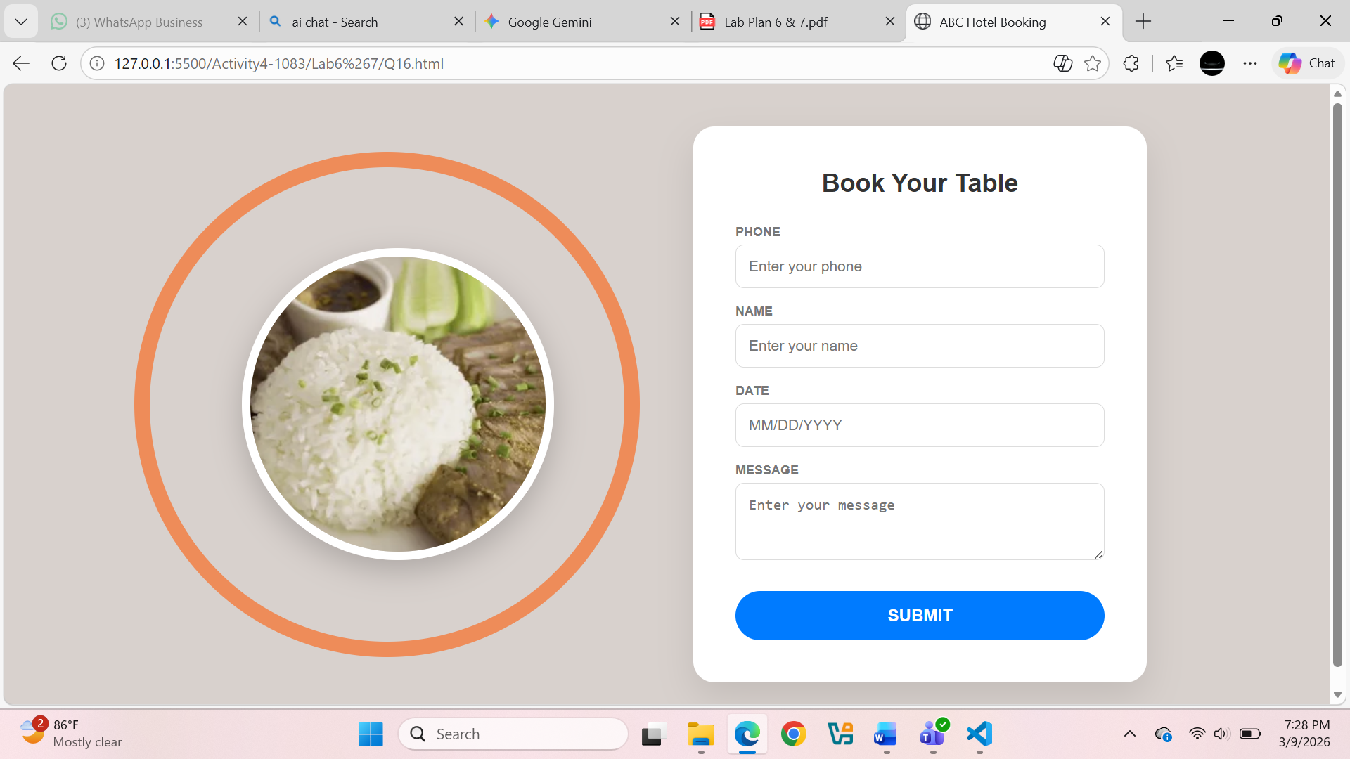
Question. No.17
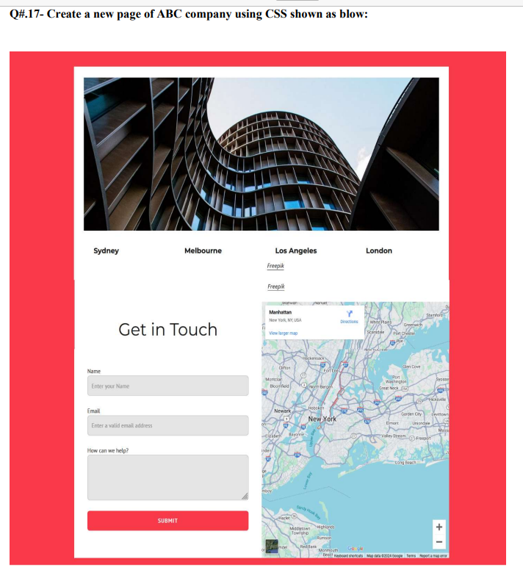
Code:
<!DOCTYPE html>
<html>
<head>
<title>ABC Company</title>

<style>

body{
font-family:Arial;
background:#ff3b4a;
margin:0;
}

/* white main box */
.main{
width:900px;
margin:50px auto;
background:white;
padding:30px;
}

/* top image */
.top img{
width:100%;
height:300px;
object-fit:cover;
}

/* city names */
.cities{
display:flex;
justify-content:space-around;
margin:20px 0;
font-weight:bold;
}

/* bottom section */
.bottom{
display:flex;
margin-top:30px;
}

/* form */
.form{
width:50%;
padding-right:20px;
}

.form h2{
font-size:30px;
margin-bottom:20px;
}

input,textarea{
width:100%;
padding:10px;
margin:10px 0;
border:1px solid #ccc;
border-radius:4px;
}

button{
width:100%;
padding:12px;
background:#ff3b4a;
color:white;
border:none;
border-radius:4px;
}

/* map */
.map{
width:50%;
}

.map img{
width:100%;
height:350px;
object-fit:cover;
}

</style>
</head>

<body>

<div class="main">

<div class="top">
<img src="Building.png">
</div>

<div class="cities">
<div>Sydney</div>
<div>Melbourne</div>
<div>Los Angeles</div>
<div>London</div>
</div>

<div class="bottom">

<div class="form">
<h2>Get in Touch</h2>

<label>Name</label>
<input type="text" placeholder="Enter your Name">

<label>Email</label>
<input type="email" placeholder="Enter a valid email address">

<label>How can we help?</label>
<textarea rows="5"></textarea>

<button>SUBMIT</button>

</div>

<div class="map">
<img src="Map.jpg">
</div>
</div>
</div>
</body>
</html>
Output:
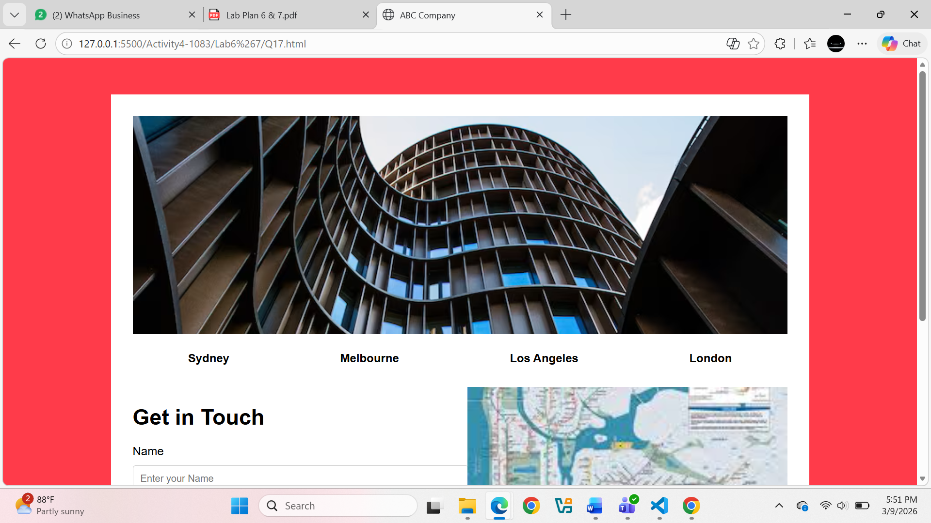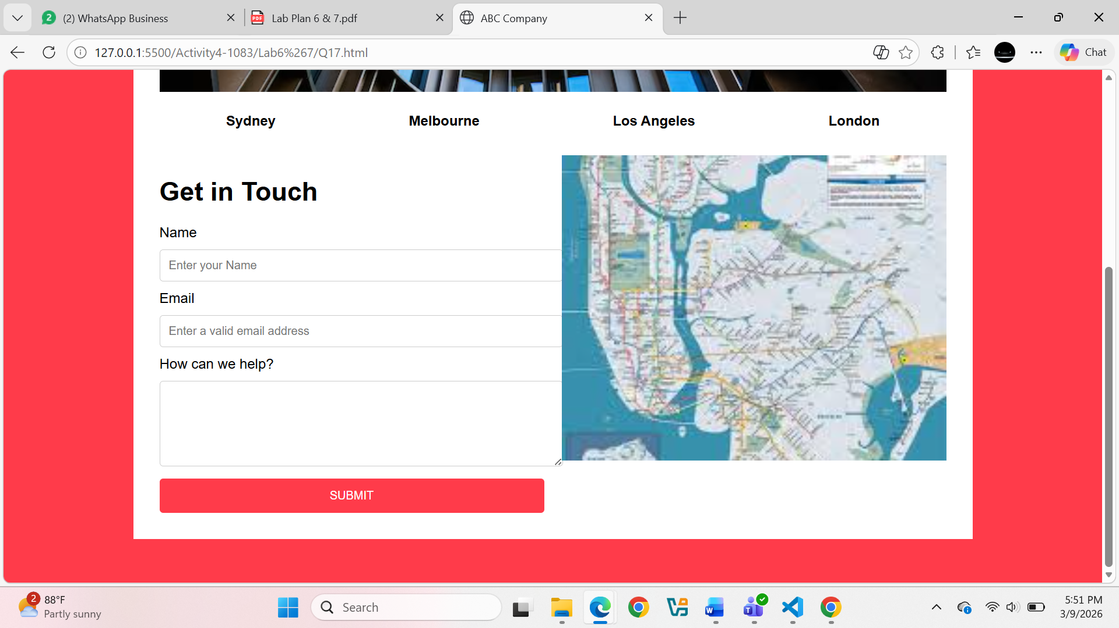
Question. No.18
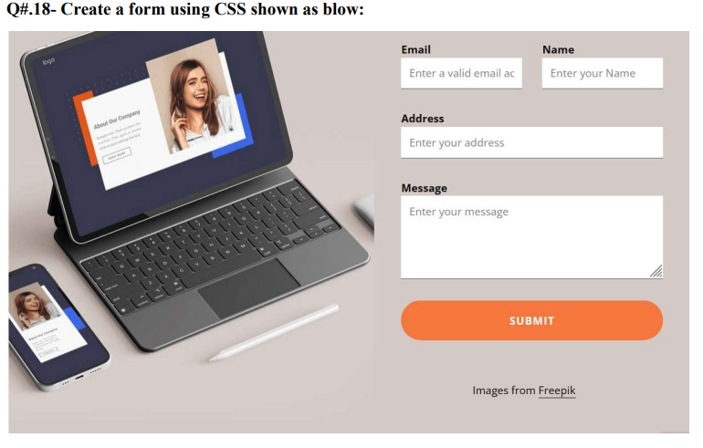
Code:
<!DOCTYPE html>
<html>
<head>
<title>Contact Form</title>

<style>
body{
font-family: Arial;
background:#d8d1cd;
}

.container{
width:800px;
margin:auto;
margin-top:40px;
display:flex;
gap:30px;
}

img{
width:350px;
}

.form-box{
width:350px;
}

input, textarea{
width:100%;
padding:8px;
margin-top:5px;
margin-bottom:15px;
}

.row{
display:flex;
gap:10px;
}

button{
width:100%;
padding:10px;
background:#f47a3c;
color:white;
border:none;
border-radius:20px;
}
</style>

</head>

<body>

<div class="container">

<div>
<img src="https://images.unsplash.com/photo-1522199755839-a2bacb67c546">
</div>

<div class="form-box">

<form>

<div class="row">
<div>
<label>Email</label>
<input type="email" placeholder="Enter a valid email">
</div>

<div>
<label>Name</label>
<input type="text" placeholder="Enter your Name">
</div>
</div>

<label>Address</label>
<input type="text" placeholder="Enter your address">

<label>Message</label>
<textarea rows="4" placeholder="Enter your message"></textarea>

<button>SUBMIT</button>

</form>
</div>
</div>
</body>
</html>
Output:
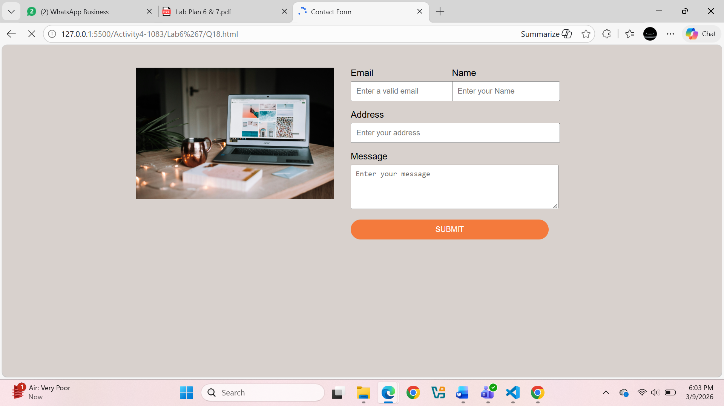
Question. No.19
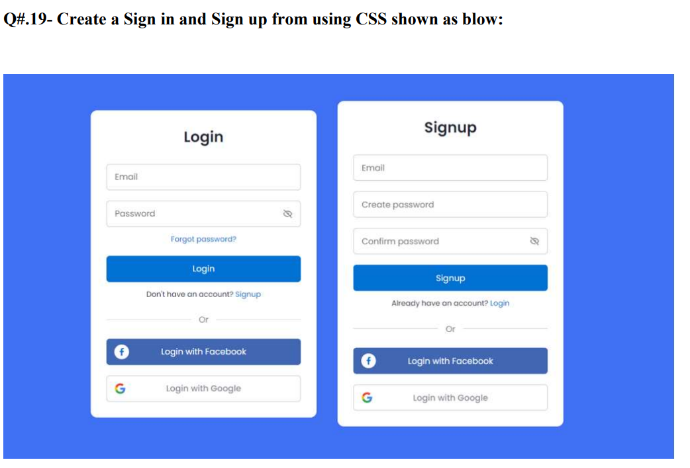
Code:
<!DOCTYPE html>
<html>
<head>
<title>Login Signup</title>

<style>
body{
font-family:Arial;
background:#3f6edb;
}

.container{
display:flex;
justify-content:center;
gap:40px;
margin-top:80px;
}

.box{
background:white;
padding:20px;
width:260px;
border-radius:10px;
}

h3{
text-align:center;
}

input{
width:100%;
padding:8px;
margin:8px 0;
}

.btn{
width:100%;
padding:8px;
margin-top:5px;
border:none;
color:white;
}

.login-btn{
background:#1e73be;
}

.fb{
background:#3b5998;
}

.google{
background:#db4437;
}
</style>

</head>

<body>

<div class="container">

<div class="box">
<h3>Login</h3>

<input type="email" placeholder="Email">
<input type="password" placeholder="Password">

<button class="btn login-btn">Login</button>

<p style="text-align:center;">Or</p>

<button class="btn fb">Login with Facebook</button>
<button class="btn google">Login with Google</button>

</div>

<div class="box">
<h3>Signup</h3>

<input type="email" placeholder="Email">
<input type="password" placeholder="Create password">
<input type="password" placeholder="Confirm password">

<button class="btn login-btn">Signup</button>

<p style="text-align:center;">Or</p>

<button class="btn fb">Login with Facebook</button>
<button class="btn google">Login with Google</button>
</div>
</div>
</body>
</html>
Output:
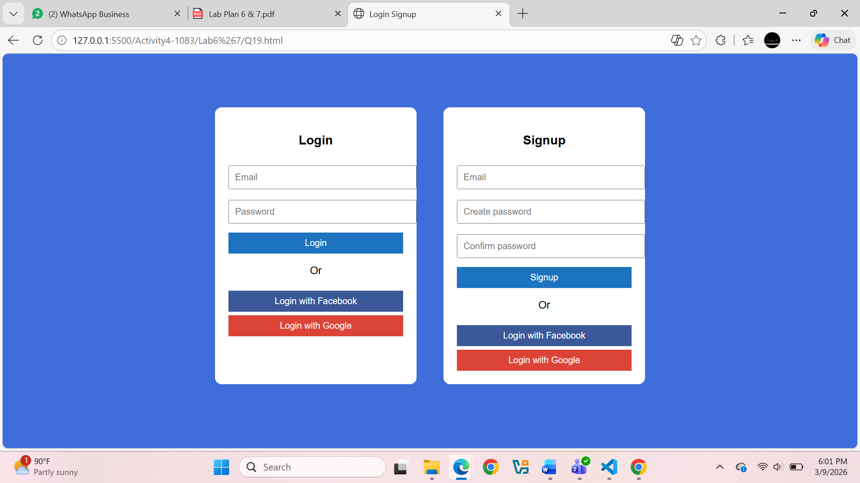Question. No.20
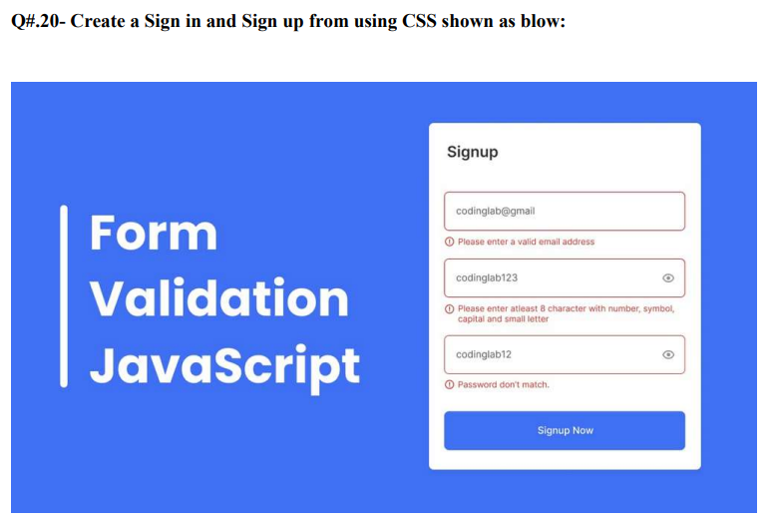
Code:
<!DOCTYPE html>
<html>
<head>
<title>Form Validation</title>

<style>
body{
font-family: Arial;
background:#4a73d9;
}

.container{
display:flex;
justify-content:space-around;
align-items:center;
margin-top:80px;
}

.left{
color:white;
font-size:40px;
font-weight:bold;
}

.form-box{
background:white;
padding:20px;
width:300px;
border-radius:8px;
}

input{
width:100%;
padding:8px;
margin:8px 0;
}

button{
width:100%;
padding:10px;
background:#4a73d9;
color:white;
border:none;
}

.error{
color:red;
font-size:12px;
}
</style>

<script>
function validateForm(){

let email=document.getElementById("email").value;
let pass=document.getElementById("pass").value;
let cpass=document.getElementById("cpass").value;

let emailError="";
let passError="";
let cpassError="";

if(!email.includes("@")){
emailError="Please enter a valid email address";
}

if(pass.length<8){
passError="Password must be at least 8 characters";
}

if(pass!=cpass){
cpassError="Password don't match";
}

document.getElementById("emailError").innerHTML=emailError;
document.getElementById("passError").innerHTML=passError;
document.getElementById("cpassError").innerHTML=cpassError;

if(emailError=="" && passError=="" && cpassError==""){
alert("Form Submitted");
return true;
}

return false;
}
</script>

</head>

<body>

<div class="container">

<div class="left">
Form<br>
Validation<br>
JavaScript
</div>

<div class="form-box">
<h3>Signup</h3>

<form onsubmit="return validateForm()">

<input type="text" id="email" placeholder="Enter Email">
<div id="emailError" class="error"></div>

<input type="password" id="pass" placeholder="Enter Password">
<div id="passError" class="error"></div>

<input type="password" id="cpass" placeholder="Confirm Password">
<div id="cpassError" class="error"></div>

<br>
<button>Signup Now</button>
</form>
</div>
</div>
</body>
</html>
Output:
